

PDD020 INTERSWITCH SETTLEMENT

PROCESS DESIGN

DOCUMENT (PDD)

|  |  |
| --- | --- |
| Process ID | 020 |
| Business Unit | Electronic Product Operations |
| Process Group | Settlement |
| Process Name | INTERSWITCH SETTLEMENT |
| Document ID | 1.0 |

|  |  |
| --- | --- |
| Version | 1.0 |
| Status | Initial Version |
| Date | 01/12/2021 |

# Contents

Contents .................................................................................................................................................. 2

Document Control ................................................................................................................................... 3

Template ............................................................................................................................................. 3

Completion stages ............................................................................................................................... 3

Version history .................................................................................................................................... 3

1. Introduction .................................................................................................................................... 4
   1. Document Purpose .................................................................................................................. 4
   2. Process Summary .................................................................................................................... 4
   3. Reference Artefacts ................................................................................................................. 4
2. Process Overview ............................................................................................................................ 5
   1. Process Diagram ...................................................................................................................... 5

High level design (HLD) – Cards & Channels -Transfer Core Settlement ............................................. 5

High level design (HLD) – Data Vending Settlement ............................................................................ 6

High level design (HLD) – NEFT Settlement ......................................................................................... 7 High level design (HLD) – POS Breakdown Settlement ........................................................................ 8

* 1. As-Is Process Description ......................................................................................................... 9
  2. Target Applications and Roles ............................................................................................... 37 RPA folder access requirements ........................................................................................................ 37
  3. Inputs and Outputs ................................................................................................................ 37
  4. Service Level Agreements...................................................................................................... 37

1. Referrals and Exceptions ............................................................................................................... 39
   1. Business Exceptions ............................................................................................................... 39
2. Non-Functional Requirements ...................................................................................................... 40
3. Process Details .............................................................................................................................. 41
   1. Work Instructions .................................................................................................................. 41
4. Risk Controls .................................................................................................................................. 45
5. Considerations ............................................................................................................................... 46
6. Operating Model ........................................................................................................................... 47
   1. Team Structure ...................................................................................................................... 47
   2. Process Timing and Operating Rhythm ................................................................................. 47
   3. Business Interaction .............................................................................................................. 48
7. Reporting ....................................................................................................................................... 48
8. Business Continuity ................................................................................................................... 48
   1. Physical workforce unavailability ....................................................................................... 48
   2. Virtual workforce unavailability ......................................................................................... 49
   3. Target application unavailability ........................................................................................ 49
   4. Excessive workload ............................................................................................................ 49
9. Business Glossary .......................................................................................................................... 49
10. Attachments .................................................................................................................................. 49
11. Complexity Estimation ................................................................................................................... 50
12. Sign-off ...................................................................................................................................... 51

# Document Control

## Template

The following person(s) own the format and information requested in this document template.

|  |  |  |
| --- | --- | --- |
| Team | Name | Relevant Sections |
| Electronic Product Operations | Festus Osayande | All |
| IT,ICEP,EPO |  | 5,6,7 |
| EPO |  | 8, 9 (All) |

The version history of this template is as follows.

|  |  |  |  |  |
| --- | --- | --- | --- | --- |
| Version | Date | Author |  | Change Summary |
| 1.0 | 28/10/2021 | Oluwafifunmi Jagun |  | • Initial Version |

## Completion stages

This document will be completed as per the following sign-off points.

|  |  |  |  |  |
| --- | --- | --- | --- | --- |
| Version | Phase | Relevant Sections | Producer | Sign-off |
| 1.0 | Scope | 1, 2, 3, 4 | Delivery Team | EPO |
| 1.0 | Design | 5, 6, 7 | Delivery Team | IT,ICEG,EPO |
| 1.0 | Test | 8, 9 (All) | Delivery Team | EPO |

## Version history

This document’s change history is as follows.

|  |  |  |  |  |  |  |  |
| --- | --- | --- | --- | --- | --- | --- | --- |
| Version | | Date | Author | Approver | Change Summary | | |
| 1.0 |  | 01/12/2021 | Oluwafifunmi Jagun | Draft | | • | Initial Version |

# 1. Introduction

## 1.1. Document Purpose

The purpose of the Process Design Document (PDD) is to capture the business-related details of the process being automated. It describes how the automated process is intended to work, including risk and data management controls. It also considers how the virtual workforce will operate alongside a human workforce. The PDD is a key input to the technical design of the solution.

## 1.2. Process Summary

The Interswitch Settlement process is aimed at balancing the bank’s position either through a debit or credit to cater for transactions done on the Interswitch platform.

## 1.3. Reference Artefacts

The BUSINESS REQUIREMENT DOCUMENT (BRD) which captures complexity of the process and the outcome of qualification of the process has been attached in the appendix of this manual.

The following artefacts should be read in conjunction with this document.

|  |  |
| --- | --- |
| Title | Version |
| BUSINESS REQUIREMENT DOCUMENT (BRD) OF INTERSWITCH SETTLEMENT | 1.0 |

# 2. Process Overview

This section describes the high-level design of the current state manual process and automated process.

## 2.1. Process Diagram

## High level design (HLD) – Cards & Channels -Transfer Core Settlement

Current-State Manual Processes

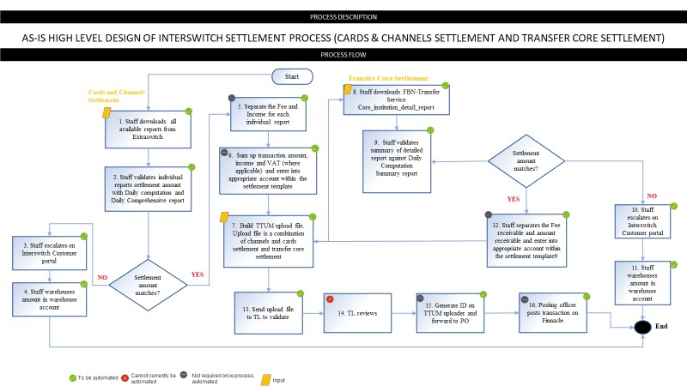

Target-State Automated Processes

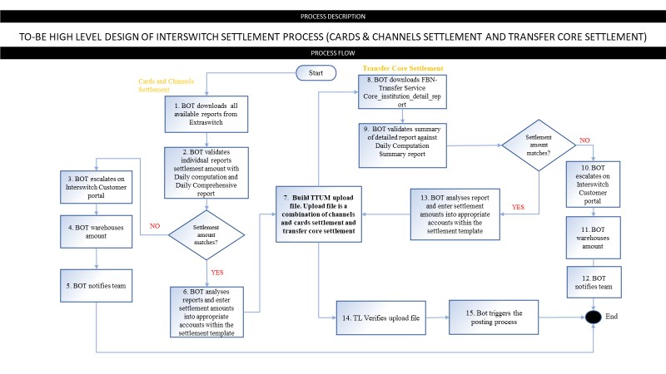

## High level design (HLD) Data Vending Settlement

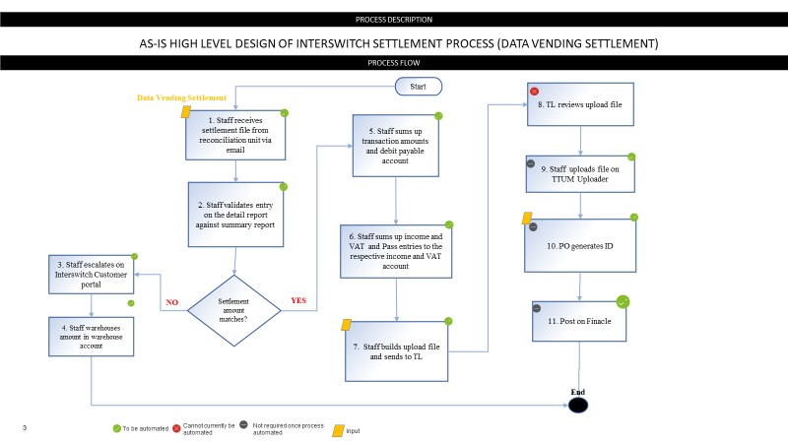

Target-State Automated Processes

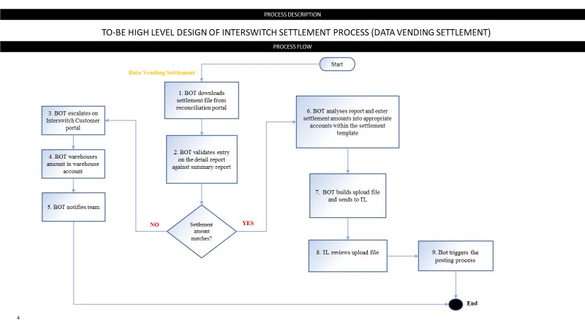

## High level design (HLD) NEFT Settlement

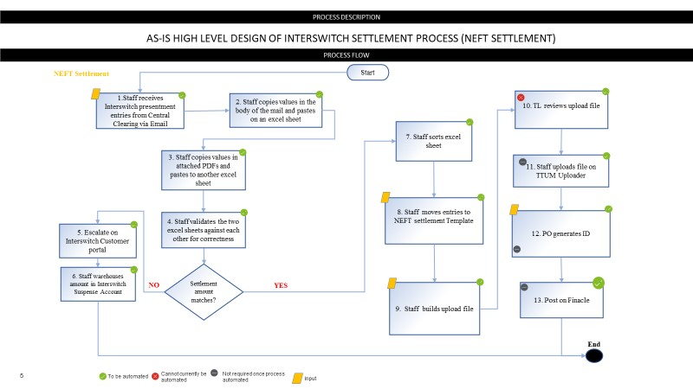

Target-State Automated Processes

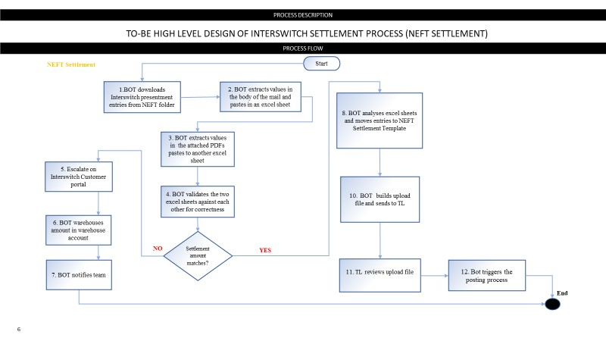

## High level design (HLD) POS Breakdown Settlement

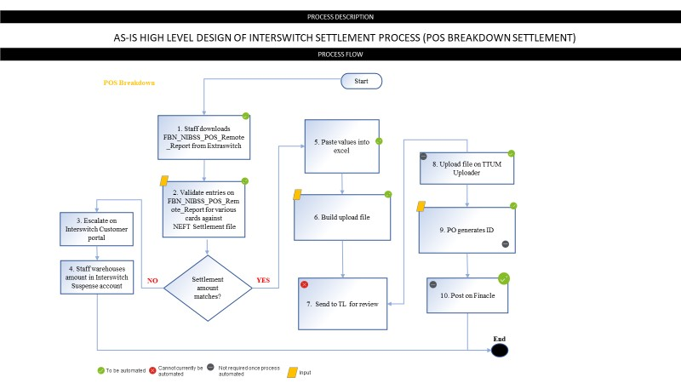

Target-State Automated Processes

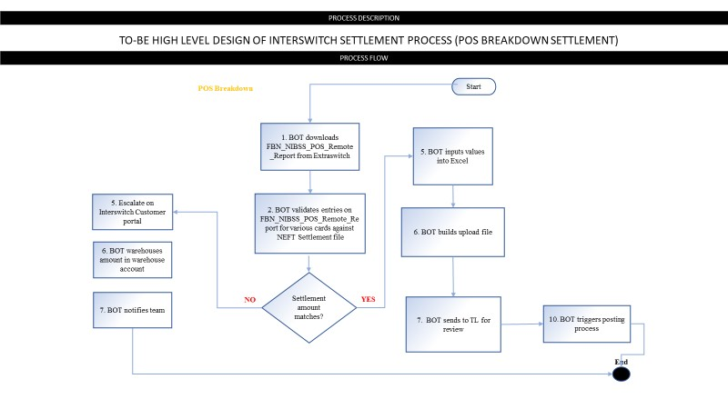

## 2.2. As-Is Process Description

This section will describe the settlement process details for Interswitch settlement. At the end of the settlement process, four upload files would be generated and posted on Finacle. These are:

* Cards and channels settlement and Transfer core settlement
* Data vending settlement
* NEFT Settlement
* POS Breakdown Settlement

2.2.1. CARDS AND CHANNELS - TRANSFER CORE SETTLEMENT

*High Level Summary*

* 1. Staff downloads reports from the Extraswitch platform.
  2. Staff validates amounts entry in each individual settlement report against FBN Daily Computation and FBN Daily comprehensive summary reports to ensure amounts are the same. *(Note: This validation is carried out for all products in the Cards and channels settlement)*
  3. Staff analyses each individual report to calculate the transaction amounts, fees, amounts and income where applicable and move entry to their respective accounts in the Interswitch Settlement template (*see for detailed settlement description for each product)*
  4. Download transfer core settlement report.
  5. Validate entry in settlement report amounts against Comprehensive/Computation summary report to ensure amounts are the same.
  6. Analyse the report. (i.e., separate into categories and move entry to template against their respective account
  7. Build combined upload file.
  8. The upload file is sent to the team lead to review.
  9. The file is uploaded on the TTUM uploader and a transaction ID is generated.
  10. TTUM upload transaction ID is sent to a posting officer who posts on Finacle using the TTUM reference and the upload file.

*Detailed Description*

Process stage 1> Staff Downloads reports from the Extraswitch platform

* Staff downloads all available reports from the Extraswitch platform by *inputting staff username and password.* 
  + - Clicks on *reports*
    - Confirms Domain is First Bank of Nigeria o Selects *All Categories* for Report Type o Inputs *current day’s date as start and end date.*

\**On a Monday, staff inputs the previous Saturday as start date and Monday as the end date. For public holiday, Staff inputs start date as the last working day and end date as the current date.*

* + - Clicks on *search*
    - Downloads each report *(The reports are checked intermittently during the day as the reports are not completely uploaded at 8am.)*
    - Saves all available reports in Interswitch folder (\\ho-rubikdb) (Z:). (*The repository contains folders with a new folder created for each month (month. Year) and within each month a different folder per day (day.month.year))*

Process stage 2 and 3> Staff validates amounts entry in each individual settlement report against summary reports. Staff analyses each report to calculate the transaction amounts, fees, amounts and income where applicable and move entry to their respective accounts in the Interswitch Settlement template. *The process stage 2 and 3 analysis for each report within the Cards and Channels- Transfer core settlement is explained in detail below. (See appendix for detailed escalation process on the Interswitch help portal)*

Products 1-17 are validated against the FBN Daily Computation report while products 18-40 are validated against the FBN Daily Comprehensive report

* 1. Agency Banking Cashout

There are two reports used in agency banking cashout settlement. These are

* *FBN_Agency_Banking_Receivable_Report*
* *FBN Agency Banking Payable Report*

* Staff opens the *FBN_Agency_Banking_Receivable_Report*
* Staff validates settlement amount o Highlight *Settlement Impact* column and sum the total transaction amount > compare the sum result with the total figure for Authorized GLO Cashout in the FBN Daily computation summary report

o if sum amount is not the same on both reports, staff warehouses the amount in the

Interswitch Suspense account and escalates via the Interswitch Customer portal o if sum amount is the same on both reports, staff proceeds with settlement

* Staff analyses the report
* sorts the report by *Trxn Categories* column to separate Agency Banking Cashout and Kimono Agency Cashout *(Please note that this step would be excluded by the BOT as the FBN_Agency_Banking_Receivable_Report would not include Kimono Agency Cashout transactions)* o Staff sorts the Agency Banking Cashout transactions by *Settlement_Impact_Desc* column to separate the fee and income > Staff separates the Transaction amount from fee
  + - Sum all amount receivable transactions > paste figure to the *amount* column of the Agent Banking REC TRX row in the Interswitch Settlement template.

(*Narration :* 48919400000901 dd.mm.yy AGENT BANKING REC TRX) o Sum all issuer fee receivable transactions > paste figure to the *amount* column of the

*Agent ROU Income line* in the Interswitch Settlement template

(*Narration:* 48955090001601 dd.mm.yy Agent ROU Income)

* + - Staff sorts the Kimono Agency Cashout transactions by *Settlement_Impact_Desc* column to separate the amount receivable from the issuer fee receivable
    - Sum all issuer fee receivable transactions > paste figure to the *amount* column of the *Kimono AGB trsf fee row* in the Interswitch Settlement template

(*Narration:*) *(Please note that this step would be excluded by the BOT as the FBN_Agency_Banking_Receivable_Report would not include Kimono Agency Cashout transactions. This analysis would be carried out under the Kimono Agency Banking settlement in the To-Be process)*

* Staff opens the *FBN_Agency_Banking_Payable_Report*
* Staff validates settlement amount o Highlight *Settlement Impact* column and sum the total transaction amount > compare the sum result with the total figure for Agency Banking Cashout in the FBN Daily computation summary report

o if sum amount is not the same on both reports, staff warehouses the amount in the

Interswitch Suspense account and escalates via the Interswitch Customer portal o if sum amount is the same on both reports, staff proceeds with settlement

* Staff analysis the report o Staff sorts the report by *Trxn_Category* column to separate Agency Banking Cashout and the Agency Banking Cashout (Verve Billing).

* + Staff sorts Agency Banking Cashout transactions by *Settlement_Impact_Desc* column to separate the *fees* and income

* + Sum the total *Acquirer fee* transactions> debit to the *amount* column of the *FAB AB WDR FEE* line in the Interswitch Settlement template *(Narration: 48934389040301*

*Narration _ dd.mm.yy FAB AB WDR FEE )* o Sum the total *Amount payable* transactions > paste the figure to the *amount* column of the *AGENT BANKING INIT TRX* line in the Interswitch Settlement template

*(Narration: 48919400000901 dd.mm.yy AGENT BANKING INIT TRX)* o Sum the total *Issuer Fee payable* transactions > paste the figure to the *amount* column of the *FAB TRSF SURCHGE* line in the Interswitch Settlement template *(Narration:*

*48934219000601 dd.mm.yy FAB TRSF SURCHGE)*

* + Staff sorts the Agency Banking Cashout (Verve Billing) transactions by *Settlement_Impact_Desc* *column* to separate the fee from the income

* + Sum the total acquirer fee payable transactions > paste the to the *amount* column of the *AGB ACQ VERVE BILLING* line in the Interswitch Settlement template. (*Narration:*

*93274800000501 dd.mm.yy AGB ACQ VERVE BILLING)* o Debit 7.5% VAT of acquirer fee payable to *VAT AGB ACQ VERVE BILLING* line in the Interswitch Settlement template. *(Narration: 93274800000501 dd.mm.yy VAT AGB*

*ACQ VERVE BILLING)* o Sum the total issuer fee payable transactions > paste figure to the *amount* column of the *AGB ACQ VERVE BILLING* line in the Interswitch Settlement template. *(Narration:*

*48975360000101 dd.mm.yy AGB ACQ VERVE BILLING)* o Debit 7.5% VAT of issuer fee payable to *VAT AGB ACQ VERVE BILLING* line in the Interswitch Settlement template.

*(Narration: 48975360000101 dd.mm.yy VAT AGB ACQ VERVE BILLING)*

2. ATM Transfers

* Staff opens *FBN_ATM_Transfers_Report*
* Staff validates settlement amount o Highlight *Settlement Impact* column and sum the total transaction amount > compare the sum result with the total figure for ATM Transfers in the FBN Daily computation summary report

if sum amount is not the same on both reports, staff warehouses the amount in the

Interswitch Suspense account and escalates via the Interswitch Customer portal o if sum amount is the same on both reports, staff proceeds with settlement

* Staff analysis report o
  + Staff sorts the *FBN_ATM_Transfers_Report* by *Trxn Category* column to separate the ATM Transfers from the Verve Billings

* + Staff sorts the ATM Transfer transactions by *Settlement_Impact_Desc* to separate the fees and income

* + Sum the total acquirer fee receivable > paste the figure to the *amount* column of the *ATM TRSF FEE ACQD* line in the Interswitch Settlement template *(Narration:*

*48955090002301 dd.mm.yy ATM TRSF FEE ACQD)*

* + Sum the total amount payable transactions > paste figure to the *amount* column of the *ATM TRSF INIT* line in the Interswitch Settlement template
  + Sum the total amount receivable transactions > paste figure to the *amount* column of the *ATM TRSF REC* line in the Interswitch Settlement template
  + Sum the total issuer fee payable transactions > paste figure to the *amount* column of the *ATM TRSF SURCHGE* line in the Interswitch Settlement template
  + Sum the total issuer fee receivable transactions > paste to the *amount* column of the *ATM TRSF FEE* line in the Interswitch Settlement template

* + Staff sorts the ATM Transfer (Verve Billing) transactions by *Settlement_Impact_Desc* column to separate the fee and income
  + Sums up total acquirer fee payable transactions > debit the *ATM TRANS ACQ VERVE BILLING* line in the Interswitch Settlement template *(Narration: debit to*

*48974800000301 dd.mm.yy ATM TRANS ACQ VERVE BILLING)* o Debit 7.5% VAT of acquirer fee payable to *ATM TRANS ACQ VERVE BILLING* line in the Interswitch Settlement template *(Narration 48974800000301 dd.mm.yy VAT ATM*

*TRANS ACQ VERVE BILLING)* o Sums up total acquirer fee payable transactions > paste figure to the *amount* column of the *ATM TRANS ACQ VERVE BILLING* line in the Interswitch Settlement template

*(Narration: 48974800000301 dd.mm.yy ATM TRANS ACQ VERVE BILLING)* o Debit 7.5% VAT of acquirer fee payable > paste figure to the *amount* column of the *VAT ATM TRANS ACQ VERVE BILLING* line in the Interswitch Settlement template

*(Narration: 48974800000301 dd.mm.yy VAT ATM TRANS ACQ VERVE BILLING)* o Sums the total issuer fee payable > debit figure to the *amount* column of the *ATM TRANS ISSUER VERVE BILLING* line in the Interswitch Settlement template (*Narration:*

*48975360000101 dd.mm.yy ATM TRANS ISSUER VERVE BILLING)* o Calculate the VAT fee (7.5%) on the total issuer fee payable > debit the *VAT ATM TRANS ISSUER VERVE BILLING* line in the Interswitch Settlement template (*Narration:*

*48975360000101 dd.mm.yy VAT ATM TRANS ISSUER VERVE BILLING)*

3. ATM Withdrawals

* Staff opens *ATM_Withdrawals_Report*
* Staff validates settlement amount

Highlight *Settlement Impact* column and sum the total transaction amount > compare the sum result with the total figure for ATM Withdrawals in the FBN Daily computation summary report

o if sum amount is not the same on both reports, staff warehouses the amount in the

Interswitch Suspense account and escalates via the Interswitch Customer portal o if sum amount is the same on both reports, staff proceeds with settlement

* Staff analysis report o Staff sort the *FBN_ATM_Withdrawals_Report* by *Trxn Category* column to separate the ATM Withdrawals (Cardless: Paycode Verve Token), ATM Withdrawals (Regular) and Verve Billing

* + Staff sorts the ATM Withdrawals (Cardless:Paycode Verve Token) transactions by *Settlement_Impact_Desc* column to separate the fee and income

* + Sum the total amount receivables > credit the *amount* column of the *NOU TRX* line in the Interswitch Settlement template*. (Narration: 48919400009701 dd.mm.yy*

*PAYCODE NOU TRNX)* o Sum the total acquirer fee receivable, Issuer fee receivable and issuer fee payable on Column R. Copy the figure and paste to the *amount* column of the *PAYCODE ATM INCOME* line in the Interswitch Settlement template.

* + Sum the total amount payable and amount receivable > paste figure to the *amount* column of the *PAYCODE ATM INCOME* line in the Interswitch Settlement template.

* + Staff sorts the ATM Withdrawals (Regular) transactions by *Settlement_Impact_Desc* to group the fee and income

* + Staff sorts the amount payable transactions by *Totals_Group* to group the transactions by the type of card used in withdrawal on another Bank’s terminal*. (see appendix 4 for the schedule of the card type and name)*

* + Sum the total amount payable for FBNGroup > paste figure to the *amount* column of the *ROU TRX* line in the Interswitch Settlement template.
  + Sum the total amount payable for FBNMCDebit > paste the figure to the *amount* column of the *Mastercard Naira – ROU* line in the Interswitch Settlement template.
  + Sum the total acquirer fee receivable > paste the figure to the *amount* column of the *FEE ON NOU TRX* line in the Interswitch Settlement template. o Staff sums the total amount receivable > paste to the *amount* column of the *NOU TRX* line in the Interswitch Settlement template

* + For the Issuer Fee Payable, Staff separates Request from Reversal in column AA to sort out the reversed transactions > Select the transactions issuer fee payable > Click *Sort & Filter* on the *Home* tab to Sort the Issuer Fee Payable transactions by Column AA (Settlement_Impact_Desc) > click *OK >* Insert blank spaces to separate the Requests from Reversals.

Insert a new column between column V and W > Copy the Retrieval Reference Number

(RRN) of all *Reversal transactions* in column V and paste to cell B2 in a new workbook

> Insert unique numbers to cell C2 o Run a VLOOKUP function on *column w*. *(The lookup value is column V; table array is columns imported to the new worksheet. Column index number is 2 and range lookup is 0)* > Sort column W to bring out the items that returned a value and insert spaces to separate the NA

* + Highlight and cut the transactions that returned value from the VLOOKUP search > paste to the reversal transaction > select the request and reversal transactions to confirm the sum is zero
  + Copy the Issuer fee transactions with *NA* to another worksheet within the ATM Withdrawal Report and rename the sheet as *Fee*

*(Note: ATM withdrawal on other Bank’s terminal attracts a NGN35 charges; the first three charges are borne by the Bank while subsequent charges are passed on to the cardholder. The issuer fee report is to be analysed to identify the charges borne by the Bank and those borne by the cardholder. A report (N35 report) is to be downloaded on OBIE platform which shows the transactions charged to the customer)*

* Staff logs on to Oracle Business Intelligence (OBIE) platform ([https://hoobieesvr:9503/analytics/saw.dll?PortalGo)](https://ho-obieesvr:9503/analytics/saw.dll?PortalGo) by inputting username and password o clicks on *dashboard*  on the *home* tab > click *firstmonie* > Click on *discovery report* o Input the *Start date* and *End date* using the MM/DD/YYYY format (*inputs previous day’s date for start date and end date)*
  + - clicks on *apply* > Click *ATM transactions – N35* > Click *export* > Click *data* > click *tab* *delimited format* > click on *open* > click *OK*
    - Insert unique numbers to column J to identify the RRN on the N35 report

* + - Run a VLOOKUP function on *column w* of the *Fee* worksheet. (*The lookup value is column V on the Fee worksheet; table array is columns I & J on the N35 report. Column index number is 2 and range lookup is 0)*

* + - Sort column W to identify the transactions that returned a value > insert spaces to separate the *NA*
    - Select the transactions with returned value and sort by column X to separate the transactions by the card type > Insert blank spaces to separate the card types. (*These are transactions whose fee will be borne by the cardholder)*
    - Change the Fee charges for FBNGroup card type from *-35* to *-31.15*; (*this is the net amount to be charged to the VERVE account)* > Sum the total Issuer Fee payable for FBNGroup on Column R > Copy the figure and paste to the *amount* column of the *ROU fee deduction on VERVE – ATM WITHD CHARGE* line in the Interswitch Settlement template.
    - Change the Fee charges for FBNMCDebit card type from *-35* to *-32.30*; (*this is the net amount to be charged to the Naira Mastercard account)* > Sum the total Issuer Fee payable for FBNMCDebit on Column R > Copy the figure and paste to the *amount* column of the *ROU fee deduction on NMC – ATM WITHD CHARGE* line in the Interswitch Settlement template.

Select the transactions with NA > sort by column X to separate the transactions by the card type > Insert blank spaces to separate the card types (i.e., FBNGroup, FBNMCDebit*) (These are transactions whose fee will be borne by the Bank)*

* + - Sum the total Issuer Fee payable for FBNGroup on Column R > Copy the figure and paste to the *amount* column of the *ROU fee deduction – VERVE – ROU FEE DEDUCTION TRX* line in the Interswitch Settlement template.
    - Sum the total Issuer Fee payable for FBNMCDebit on Column R > Copy the figure and paste to the *amount* column of the *ROU fee deduction – Naira Mastercard – ROU FEE DEDUCTION TRX* line in the Interswitch Settlement template

4. Kimono Agency Banking

* Staff opens the *FBN_Other_Transfers_Report*
* Staff validates settlement amount o Highlight *Settlement Impact* column and sum the total transaction amount > compare the sum result with the total figure for Kimono Agency Banking in the FBN Daily computation summary report

o if sum amount is not the same on both reports, staff warehouses the amount in the

Interswitch Suspense account and escalates via the Interswitch Customer portal o if sum amount is the same on both reports, staff proceeds with settlement

* Staff analysis report o Staff sorts *FBN_Other_Transfers_Report* transactions by *Trxn_Category* to separate the three products within the Other Transfer Reports – KIMONO AGENCY CASHOUT REV POC, OTHER QT SVA POS AGENCY CASHOUT and POS TRANSFERS > Copy and paste the other two products (i.e., Other QT Transfer SVA POS AGENCY CASHOUT and POS

Transfers) to new worksheets o Staff sorts Kimono Agency Cashout REV POC transactions by *Trxn_Category* to separate the Kimono Agency Cashout REV POC and Kimono Agency Cashout REV POC (Verve

Billings)

* + Staff sorts all Kimono Agency Cashout REV POS transactions by

*Settlement_Impact_Desc* column to separate the fees and income

* + Sum the total amount payable transactions > debit figure to the *amount* column of the Kimono AGB Cashout REV POC line in the Interswitch Settlement template. (*Narration: debit to 48919400000901 dd.mm.yy KIMONO AGB CASHOUT REV POC)*
  + Sum the total Issuer Fee payable > debit the *amount* column of the Fee on Kimono TRSF INIT line in the Interswitch Settlement template *(Narration: 48934219000601 dd.mm.yy FEE ON KIMONO TRSF INIT)*
  + Sum the total Issuer Fee receivable transactions > credit to the *amount* column of the Kimono AGB TRSF Fee line in the Interswitch Settlement template (*Narration:*

*48955090001601 dd.mm.yy KIMONO AGB trsf fee)*

* + Staff sorts all Kimono Agency Cashout REV POS (Verve Billings) transactions by *Settlement_Impact_Desc* column to separate the fees and income

Sum the total Issuer Fee payable for Kimono Agency Cashout Rev POC (Verve Billing) >

Calculate the VAT fee (7.5%) on the total Issuer fee payable o Copy the total Issuer fee payable figure and VAT figure to the *amount* column of the Kimono AGB Cashout REV POC Issuer Verve Billing and VAT Kimono AGB Cashout REV POC Issuer Verve Billing lines respectively in the Interswitch Settlement template.

5. Other QT Transfers

* Staff opens the *FBN_Other_Transfers_Report*
* Staff validates settlement amount o Highlight *Settlement Impact* column and sum the total transaction amount > compare the sum result with the total figure for Other QT Transfers in the FBN Daily computation summary report

o if sum amount is not the same on both reports, staff warehouses the amount in the

Interswitch Suspense account and escalates via the Interswitch Customer portal o if sum amount is the same on both reports, staff proceeds with settlement

* Staff analysis the report o Staff sorts the *FBN_Other_Transfers_Report* by *Trxn Category* column to separate the Other QT SVA POS Agency Cashout transactions and Other QT SVA POS Agency Cashout transactions Billings

* + Staff sorts the Other QT SVA POS Agency Cashout transactions by *Settlement_Impact_Desc* to separate the fees and income

* + Sum the total Amount payable transactions > debit to the amount column of the *Other QAGB TRSF INIT* line in the Interswitch Settlement template *(Narration: 48919400000901 dd.mm.yy other QAGB TRSF INIT )*
  + Sum the total amount receivable transactions > credit to the *amount* column of the *Other QAGB TRSF REC* line in the Interswitch Settlement template *(Narration: 48919400000901 dd.mm.yy other QAGB TRSF REC)*
  + Sum the total issuer fee payable transactions > debit to the *amount* column of the *Other Fee on QAGB TRSF INIT* line in the Interswitch Settlement template *(Narration:*

*48934219000601 dd.mm.yy other FEE ON QAGB TRSF INIT)* o Sum the total issuer fee receivable less VAT > credit to the *amou*nt column of the *Other Qteller AGB Trsf Fee* line in the Interswitch Settlement template *(Narration: 48957000003001 dd.mm.yy other Qteller AGB trsf fee)*

* + For the Other QT SVA POS Agency Cashout (verve Billing), Staff sums up the total issuer fee payable > debit the OTHER QT AGB TRANS ISSUER VERVE BILLING line in the Interswitch Settlement template *(Narration: 48975360000101 dd.mm.yy OTHER QT AGB TRANS ISSUER VERVE BILLING)*

* + Calculate the VAT fee (7.5%) on the total Issuer fee payable > debit to VAT OTHER QT AGB TRANS ISSUER VERVE BILLING line int the Interswitch Settlement template *(Narration:*

*48975360000101 dd.mm.yy VAT OTHER QT AGB TRANS ISSUER VERVE BILLING*)

6. POS Transfer

* Staff opens the *FBN_Other_Transfers_Report*
* Staff validates settlement amount

Staff opens the *POS transfer* worksheet o Highlight *Settlement Impact* column and sum the total transaction amount > compare the sum result with the total figure for POS Transfer in the FBN Daily computation summary report

o if sum amount is not the same on both reports, staff warehouses the amount in the

Interswitch Suspense account and escalates via the Interswitch Customer portal o if sum amount is the same on both reports, staff proceeds with settlement

* Staff analysis the report o Staff sort the *POS transfer* worksheet by *Trxn Category* column to separate the POS Transfers transactions and POS Transfers (Verve Billings)

* + Staff sorts all POS Transfer transactions by *Settlement_Impact_Desc* to separate the fees and income

* + Sum the total amount payable for POS Transfers > debit to the *amount* column of the *POS TRSF INIT* line in the Interswitch Settlement template *(Narration: 48919400000901 dd.mm.yy POS TRSF INIT)*
  + Sum the total amount receivable > credit to the *amount* column of the *POS TRSF REC* line in the Interswitch Settlement template *(Narration: 48919400000901 dd.mm.yy POS TRSF*

*REC)* o Sum the total issuer fee payable > debit to the *amount* column of the *POS TRSF ISSUER FEE* line in the Interswitch Settlement template *(Narration: 48955090001601 dd.mm.yy*

*POS TRSF ISSUER FEE)* o Sum the total issuer fee receivable transactions > paste the figure to the *amount* column of the *POS TRSF ISSUER FEE* line in the Interswitch Settlement template (*Narration: 48955090001601 dd.mm.yy POS TRSF ISSUER FEE)*

* + For the POS Transfers (Verve Billings), sum the total Issuer Fee payable > debit to *POS TRS ISSUER VERVE BILLING* *(Narration: 48975360000101 dd.mm.yy POS TRS ISSUER VERVE*

*BILLING)* o Calculate the VAT fee (7.5%) on the total Issuer fee payable > debit to *VAT POS TRS ISSUER VERVE BILLING (Narration: 48975360000101 dd.mm.yy VAT POS TRS ISSUER VERVE BILLING*)

7. Autopay

* Staff opens the *FBN _Autopay_Report*
* Staff validates settlement amounto Highlight *Settlement Impact* column and sum the total transaction amount > compare the sum result with the total figure for Autopay in the FBN Daily computation summary report

o if sum amount is not the same on both reports, staff warehouses the amount in the

Interswitch Suspense account and escalates via the Interswitch Customer portal o if sum amount is the same on both reports, staff proceeds with settlement Staff analysis the report

* Staff analysis the report
* Staff sorts the *FBN _Autopay_Report* by *Settlement_Impact_Desc* column to separate the fees and income

* Staff sorts the amount payable transactions by *Account_ID* to group the transactions by the account (*i.e., the NUBAN account (which is the regular 10-digit account number) and the*

*Autopay account (which is the regular 19-digit account number*)) o Sum the total amount payable for NUBAN account > paste to the *amount* column of the *Autopay INIT TRX* line in the Interswitch Settlement template. *(Narration:*

*48919400007401 dd.mm.yy AUTOPAY INIT TRX)*

* For the total amount payable for Autopay account > copy all *PAN numbers* in column I and their respective *amount* in column Z > Paste to a new workbook to aggregate the value that is attributed to a particular card > Select all transactions in the new workbook and sort by column A

* Create a pivot table to aggregate the subtotal for each card > Select all transactions > Click *Insert* on the *Home* tab > Click *PivotTable* > Click *OK* on the Create *PivotTable* pop up > Select the headers for rows and value > Copy the Pivot Table result and paste to a new worksheet
* Copy the figure for each card PAN and paste to the *amount* column for each card PAN in the Interswitch Settlement template. (*For Instance, for the card pan with 1608 last 4 digits, copy the figure, and paste to the amount column of the Autopay INIT 1608 TRX line in the Interswitch Settlement template).*

* Staff sums the total amount receivable transactions > paste the figure to the *amount* column of the *AUTOPAY REC TRX* line in the Interswitch Settlement template. *(Narration: 48919400007401 dd.mm.yy AUTOPAY REC TRX)*

* Staff sorts Issuer Fee Payable transactions by *account ID* to group the transactions by the account
* Sum the total Issuer Fee payable for NUBAN account > paste to the *amount* column of the *FEE on Autopay* line in the Interswitch Settlement template*. (Narration : 95034303001801 dd.mm.yy FEE ON AUTOPAY)*

* For the total issuer fee payable for Autopay account > copy the *PAN number* in column I and *amount* in column Z > Paste to a new workbook to aggregate the value that is attributed to a particular card > Select all transactions in the new workbook and sort by column A

* Create a pivot table to aggregate the subtotal for each card > Select all transactions > Click *Insert* on the *Home* tab > Click *PivotTable* > Click *OK* on the Create *PivotTable* pop up > Select the headers for rows and value > Copy the PivotTable result and paste to a new worksheet
* Copy the figure for each card PAN and paste to the *amount* column for each card PAN in the Interswitch Settlement template. (*For Instance, for the card pan with 1608 last 4 digits, copy the figure, and paste to the amount column of the Autopay INIT 1608 TRX line in the Interswitch Settlement template).*

* Sum the total Issuer Fee Receivable > paste the figure to the *amount* column of the *Income on Autopay TRX* line in the Interswitch Settlement template.

8. Bill Payment

* Staff opens the *FBN_Billpayment_Report*
* Staff validates settlement amounto Highlight *Settlement Impact* column and sum the total transaction amount > compare the sum result with the total figure for Bill Payment in the FBN Daily computation summary report
  + if sum amount is not the same on both reports, staff warehouses the amount in the

Interswitch Suspense account and escalates via the Interswitch Customer portal o if sum amount is the same on both reports, staff proceeds with settlement

* Staff analysis the report o Staff sort *FBN_Billpayment_Report* by *settlement_impact_desc* column to separate the fee and income.
  + Select all transaction > click on *filter* on the *Home* tab > Click the dropdown list on column W and unselect Amount payable and Amount receivable > Click *OK* > Copy the open

transactions and paste to a new worksheet within the Bill payment report

* + Sort the transactions by *Trxn_Category to* separate the Bill Payment and the Verve Billing > Cut the Verve Billing transactions and paste to a new worksheet within the Billing payment workbook and name as *Verve Billing*

* + Sort theBill payment transactions by *Settlement_Impact_Desc* to separate fee and income.

* + Sum the total Acquirer fee payable and acquirer fee receivable transactions. Copy the figure and paste to the *amount* column of the *BILL PAY ACQD FEE* line in the Interswitch Settlement template.
  + Sort the Issuer Fee Payable transactions by *Terminal ID* – *The below schedule shows the identification of the various Terminal type)*

|  |  |  |
| --- | --- | --- |
| SN | Unique Identifier | Terminal Type |
| 1 | 10****** | ATM Terminal |
| 2 | 21SW**** | ATM Terminal |
| 3 | 3FNT**** | Online Internet Payment |
| 4 | 3FAP**** | Mobile Transactions |
| 5 | 4NCH**** | Firstmonie Transactions |

* + Sum the total Issuer Fee Payable for 2011xxx – 3BOL0001 > paste figure to the *amount* column of the *BILL PYMT SURCHG* line in the Interswitch Settlement template. (*Narration:*

*48934219000601 BILL PYMT SURCHG)*

* + Sum *Surcharge*_ Issuer_fee_payable column (column T) for 3FAB0001 > Copy the figure and paste to the *amount* column of the *FAB BILL PYMT TRX FEE* line in the Interswitch Settlement template > sum *Settlement Impact* Issuer fee payable column (column V) for 3FAB0001 > calculate the difference between the Total surcharge amount (column T) and Settlement Impact (column V) which is the income to the Bank. *Credit AB SVA BILL PAY FEE* line in the Interswitch Settlement template *(Narration: 48934389034501 AB SVA BILL*

*PAY FEE)* o Sum Issuer_fee_payable and Issuer_fee_receivable for 3FBB0001 > paste figure to *WHP*

*BILL PAY TRX FEE* line in the Interswitch Settlement template *(Narration: 48934389019901*

*WHP BILL PAY TRX FEE)* o Sum *Surcharge* Issuer_fee_payable for 3FNT0001 – 3ONC0001 > paste to the *amount* column of the *BILL PYMT SURCHG Ibanking* line in the Interswitch Settlement template

*(Narration: 48934219000601 BILL PYMT SURCHG IBANKING) >* Sum

Settlement_Impact Issuer_fee_payable for 3FNT0001 – 3ONC0001 > Find difference of Sum *Surcharge_* Issuer_fee_payable and Sum *Settlement_Impact* Issuer_fee_payable > Credit *to BILL PAY SVA FEE* line in the Interswitch Settlement template (*Narration:*

*95055030000801 BILL PAY SVA FEE)* o Sum *Surcharge_* Issuer_fee_payable for 4FAP0001& 4NCH0001 > paste to the *FAP BILL PAY*

*TRX FEE* line in Interswitch Settlement template *(Narration: 48934389019901 FAP BILL PAY TRX FEE)* (ensure to change the surcharge for 4NCH0001 to -35 as against the 100 seen on the report) *>* Sum *Settlement_Impact* Issuer_fee_payable for 4FAP0001 & 4NCH0001 > calculate the difference between the Total *surcharge amount* and *Settlement Impact* > Calculate the portion of Income to the Bank (60%) and Implementation partner (40%).

* Paste the bank’s portion of income to *FAP BILL PAY INCOME* line in Interswitch Settlement template *(Narration: 48957000002901 FAP BILL PAY INCOME)*
* Paste the implementation partner’s portion of income to *PARTNER REBATE- BILLS* line in

Interswitch Settlement template *(Narration: 2030127898 Partner Rebate- Bills)*

• Staff sorts the Issuer fee receivable within the Bill payment worksheet by *Card Pan* to separate the various Cards. *The below schedule shows the various cards using the first 6 digits of the PAN*

|  |  |  |
| --- | --- | --- |
| SN | Card | Unique Identifier |
| 1 | MasterCard | 539923 |
| 2 | MasterCard | 519878 |
| 3 | Verve Card | 506105 |
| 4 | Verve Card | 650003 |
| 5 | Verve Card | 506145 |
| 6 | VISA card | 470655 |
| 7 | VISA card | 470651 |
| 8 | VISA card | 427011 |
| 9 | Virtual Card | 628051 |

* Sum the total value Issuer fee receivable for Visa Cards (470655, 470651, 427011) > paste to the *amount* column of the *BILL PAY ISSUER FEE* line in the Interswitch Settlement template (*Narration: 48957000002601 BILL PAY ISSUER FEE)*
* Sum the total value Issuer fee receivable for Verve Card > paste figure to the *amount* column of the *BILL PAY ISSUER FEE* line in the Interswitch Settlement template

*(Narration: 48955090001601 BILL PAY ISSUER FEE)* o Sum the total value Issuer fee receivable for MasterCard > paste the figure to the *amount* column of the *BILL PAY ISSUER FEE* line in the Interswitch Settlement template *(Narration: 48957000001401 BILL PAY ISSUER FEE)*

• Staff sorts Virtual cards transactions by *Terminal ID* column to separate the various Terminals. The below schedule shows the various Terminals ( 3FAB0001, 3FNT0001 – 3ONC0001, 4NCH0001 and 4FAP0001)

|  |  |  |
| --- | --- | --- |
| SN | Unique Identifier | Terminal Type |
| 1 | 3FNT**** | Online Internet Payment |
| 2 | 3FAP**** | Mobile Transactions |
| 3 | 4NCH**** | Firstmonie Transactions |

* Sum the total value for Online Internet Payment (3FNT0001 – 3ONC000) > paste to the *amount* column of the *BILL PAY ISSUER FEE* line in the Interswitch Settlement template *(Narration:*

*95055030000801 BILL PAY ISSUER FEE)*

* Sum the total value for Mobile Transactions > paste to the *amount*  column of the *BILL PYMT FEE* line in the Interswitch Settlement template *(Narration: 48934389034501 BILL PYMT*

*FEE)* o Sum the total value for Firstmonie Transactions (4FAP0001 & 4NCH0001) > paste to the *amount* column of the *FAP* *BILL PAY ISSUER FEE* line in the Interswitch Settlement template (*Narration: 48957000002901 FAP BILL PAY ISSUER FEE)*

* Staff sorts the Verve Billing worksheet by *settlement impact description* column to separate the Bill payment (verve billing) and Recharge (verve billing)

* Sort the Bill payment (verve billing) transactions by *Settlement_Impact_Desc* to sort the transactions by Acquirer Fee and Issuer Fee payable

* Sum the total Acquirer fee payable > debit to *BILLPAY V/BILLING ACQ* line in the Interswitch

Settlement template *(Narration: 48974800000301 dd.mm.yy BILLPAY V/BILLING ACQ)* o Calculate the VAT fee (7.5%) on the total acquirer fee payable > Debit to *BILLPAY V/BILLING ACQ VAT* line in the Interswitch Settlement template *(Narration: 93274800000501 dd.mm.yy*

*BILLPAY V/BILLING ACQ VAT)* o Sum the total Issuer fee payable > debit to *BILLPAY VERVE BILLING* in the Interswitch Settlement template *(Narration: 48975360000101 dd.mm.yy BILLPAY VERVE BILLING)*

* Calculate the VAT fee (7.5%) on the total acquirer fee payable > debit to the *amount* column of the *BILLPAY VERVE VAT* line in the Interswitch Settlement template *(Narration: 48975360000101 dd.mm.yy BILLPAY VERVE BILLING-VAT)*

• Staff sorts Recharge (Verve Billing) by *Settlement_Impact_Desc* to separate the Acquirer Fee and Issuer Fee payable

o Sum the total Acquirer fee payable > debit to *RCHG V/BILLING ACQ FEE* line in the Interswitch

Settlement template (*Narration: 48974800000301 dd.mm.yy RCHG V/BILLING ACQ FEE*) o Calculate the VAT fee on the total acquirer fee payable > debit to *RCHG V/BILLING ACQ FEEVAT* line in the Interswitch Settlement template. (*Narration: 93274800000501 dd.mm.yy*

*RCHG V/BILLING ACQ FEE-VAT)* o Sum the total Issuer fee payable > debit to *RCHG V/BILLING FEE* line in the Interswitch

Settlement template *(Narration: 48975360000101 dd.mm.yy RCHG V/BILLING FEE)* o Calculate the VAT fee on the total Issuer fee payable > debit *to RCHG V/BILLING FEE VAT* line in the Interswitch Settlement template (*Narration: 48975360000101 dd.mm.yy RCHG V/BILLING FEE VAT*)

9. Web

* Staff opens the *FBN_WEB_Report*
* Staff validates settlement amounto Highlight *Settlement Impact* column and sum the total transaction amount > compare the sum result with the total figure for Web in the FBN Daily computation summary report

o if sum amount is not the same on both reports, staff warehouses the amount in the

Interswitch Suspense account and escalates via the Interswitch Customer portal o if sum amount is the same on both reports, staff proceeds with settlement

* Staff analysis the report o Staff sort *FBN_WEB_Report* by  *trxn_cateory* to isolate WEB PURCHASE (VERVE BILLING)

Others:

* Filter out Acquirer_fee_payable and Amount_receivable o Aggregate Terminal_ID, Merchant_ID and Merchant_Name_Location o Aggregate per Merchant and process to Merchant Account o WEB ACQ TRX @ dd.mm.yy o Account numbers below (Filter Out Acquirer_fee_receivable Merchant_ID).

* Filter out Amount_Payable and Issuer_fee_receivable o Sort by Totals_Group and Settlement_Impact_Desc o Separate into FBNGroup and FBNMCDebit

For FBNGroup, o Sum Amount_Payable Settlement_Impact (48934385001201 REM WEB TRX)

* + - Sum Issuer_fee_receivable less VAT Settlement_Impact (48955090001601 FEE ON REM WEB TRX)

For FBNMCDebit, o Sum Amount_Payable Settlement_Impact (48934389024301 REM WEB TRX)

* + - Sum Issuer_fee_receivable less VAT Settlement_Impact (48957000001401 FEE ON REM WEB TRX)

* Filter Out Acquirer_fee_receivable Merchant_ID, o COLPAYICSANIGER Sum (95057000003001 FEE ON WEB ACQ ICSAN)

* + - COLPAYNGISCENG2 Sum (95057000003001 FEE ON WEB ACQ NSE)

* + - COLPAYADLEKEFBN, COLPAYEALAYANDE, COLPAYBIGCCONSL, COLPAYTHEPOLYIB, COLPAYCOLUMBN01, COLPAYCRESCEABK, COLPAYMENTLDIP1, COLPAYMENTLDIP2,

COLPAYJASPERBOR, COLPAYKWRCELAFI, COLPAYLAUTECPGD, COLPAYPRLAUTECH,

COLPAYOFAHLTFBN, COLPAYUNIOSNSET, COLPAYOYOSCAGRI, COLPAYSPEDVENTS,

COLPAYSPEDVNLAC, COLPAYOKEOGUNPS, and FBN235343038201 Sum (95057000003001 FEE ON WEB ACQ NSE)

* + - FBN002027275760, PAYDIRECTEEDC55, PAYDIRECTEEDC12, PAYDIRECTEEDC86, PAYDIRECTEEDC88, PAYDIRECTEEDC93, PAYDIRECTEEDC97, PAYDIRECTEEDC82,

PAYDIRECTEEDC03, PAYDIRECTEEDC38, PAYDIRECTEEDC32, PAYDIRECTEEDC20,

PAYDIRECTEEDC04, PAYDIRECTEEDC09, PAYDIRECTEEDC72, FBN406408650526, FBN002033300191, WEBPAYDIRECTTOS, and

* + - FBN002033219428 Sum (48957000003001 WEB ACQ FEE)

* Filter Out ISO_fee_receivable o Sort by Terminal_ID o Sum per merchant and process to the account o First level (48957000003001 WEB ISO FEE) o Second level (95057000003001 WEB ISO FEE)

* For the isolated WEB PURCHASE (VERVE BILLING) o Staff sorts by Settlement_Impact_Desc column
  + Sum up total Acquirer_fee_payable and debit to 48975360000801 dd.mm.yy WEB VERBILLING

ACQ FEE o Debit 7.5% VAT of Acquirer_fee_payable to 48975360000801 dd.mm.yy WEB VERBILLING ACQ

VAT o Sum up total Issuer_fee_payable and debit to 48975360000101 dd.mm.yy WEB VERBILLING

FEE o Debit 7.5% VAT of Issuer_fee_payable to 48975360000101 dd.mm.yy WEB VERBILLING FEE VAT

10. MASTERCARD LOCAL PROCESSING BILLING

* Staff opens the *FBN_Msc_Local_Proc_Report*
* Staff validates settlement amounto Highlight *Settlement Impact* column and sum the total transaction amount > compare the sum result with the total figure for MASTERCARD LOCAL PROCESSING BILLING in the FBN

Daily computation summary report o if sum amount is not the same on both reports, staff warehouses the amount in the

Interswitch Suspense account and escalates via the Interswitch Customer portal

o if sum amount is the same on both reports, staff proceeds with settlement

* Staff analysis the report o Staff sorts report by  *VAS_Channel to isolate BillPayment, POS_Purchase, Recharge and Web_Purchase.*

o Sum up to Bill payment (48975360001201 dd.mm.yy ISW SETT FOR BILL MCARD TRX) o 7.5% of Bill payment sum (48975360001201 dd.mm.yy ISW VAT FOR BILL MCARD TRX) o Sum up to POS_Purchase (48975360001201 dd.mm.yy ISW SETT FOR POS MCARD TRX) o 7.5% of Bill POS_Purchase (48975360001201 dd.mm.yy ISW VAT FOR POS MCARD TRX) o Sum up to Recharge (48975360001201 dd.mm.yy ISW SETT FOR BILL MCARD TRX) o 7.5% of Recharge sum (48975360001201 dd.mm.yy ISW VAT FOR BILL MCARD TRX) o Sum up to Web_Purchase (48975360001201 dd.mm.yy ISW SETT FOR BILL MCARD TRX) o 7.5% of Web_Purchase sum (48975360001201 dd.mm.yy ISW VAT FOR BILL MCARD TRX)

11. MasterCard ATM ROU Billing and MasterCard ATM ROU Billing_(VAT)

* Staff copies the amount for MasterCard ATM ROU Billing and MasterCard ATM ROU Billing_(VAT) as provided in the FBN Daily Computation Report and paste to the *amount* column of the *POS TRS ISSUER VERVE Billing* and *VAT POS TRS ISSUER VERVE Billing* lines respectively in the Interswitch Settlement template.

12. MasterCard POS Purchase Processor Billing and MasterCard POS Purchase Processor Billing_(VAT)

* Staff copies the amount for MasterCard POS Purchase Processor Billing and MasterCard POS Purchase Processor Billing_(VAT) as provided in the FBN Daily Computation Report and paste to the *amount* column of the *ISW SETT FOR POS ACQD MCARD TRX* and *ISW VAT FOR POS ACQD MCARD TRX* lines respectively in the Interswitch Settlement template.

13. MasterCard POS Purchase PTSP Billing and MasterCard POS Purchase PTSP Billing _(VAT)

* Staff copies the amount for MasterCard POS Purchase PTSP Billing and MasterCard POS Purchase PTSP Billing_(VAT) as provided in the FBN Daily Computation Report and paste to the *amount* column of the *ISW SETT FOR POS PTSP MCARD TRX* and *ISW VAT FOR POS PTSP MCARD TRX* lines respectively in the Interswitch Settlement template.

14. VISA ATM ROU Billing and VISA ATM ROU Billing_(VAT)

* Staff copies the amount for VISA ATM ROU Billing and VISA ATM ROU Billing_(VAT) as provided in the FBN Daily Computation Report and paste to the *amount* column of the *ISW VISA ATM ROU FEE* and *ISW VISA ATM ROU VAT FEE* lines respectively in the Interswitch Settlement template.

15. Prepaid Card Load

* Staff opens the *FBN_Prepaid_Card_Load_Report*
* Staff validates settlement amounto Highlight *Settlement Impact* column and sum the total transaction amount > compare the sum result with the total figure for Prepaid Card Load in the FBN Daily computation summary report
  + - if sum amount is not the same on both reports, staff warehouses the amount in the

Interswitch Suspense account and escalates via the Interswitch Customer portal o if sum amount is the same on both reports, staff proceeds with settlement

* + - Staff analysis the report
    - Select *Retrieval_Reference_Nr* (Column X) > highlight duplicate values > click on conditional formatting > Click on highlight cell rules > Click OK. (*The duplicate values have the same*

*RRN and both debit and credit entries in the report; the sum of the duplicate will equal zero)* o Select all transactions > Sort by column X (Retrieval_Reference_Nr) > Click the Sort on dropdown list and select Font color > Select the color in the Order column > Click OK

* + - Sum the duplicate transactions on *Settlement_Impact* column (column T) to confirm the value is zero (*Note: the total sum of the duplicate values will be zero) >* Insert blank spaces to separate the duplicates transactions
    - Sort the duplicate transactions by *Channel_Description* column to group the transaction by the various channels
    - Sort the Autopay transactions by *Settlement_Impact_Desc* column to separate Amount payable and Amount receivables
    - Sum the total Amount payable for Autopay on *Settlement Impact* column > Copy the figure and paste to the *amount* column of the *Other TRX* line in the Interswitch Settlement template.
    - Sort the Account receivable transactions by *Card_Account* column to group the transactions by the initiated account (*Note: the initiating account is identified by the last four digits of the card account in column M*)
    - Sum the total amount in column T (*settlement_Impact*) for each card account and process. For instance (48934389040901 CARDLOAD **** being the last 4 digits of Card_Account_Nr)

* + - Sort the non-duplicate transactions by column M (*Card_Account*) to group the transactions by the initiated account *(Note: the initiating account is identified by the last four digits of the card account in column M )*

* + - Sum *settlement impact* for each *card_account*

16. Quick Teller Transfer

* Staff open the FBN_QT_Transfers_Report
* Staff validates settlement amount o Highlight *Settlement Impact* column and sum the total transaction amount > compare the sum result with the total figure for QT Transfers in the FBN Daily computation summary report
  + if sum amount is not the same on both reports, staff warehouses the amount in the Interswitch

Suspense account and escalates via the Interswitch Customer portal o if sum amount is the same on both reports, staff proceeds with settlement

* Staff analysis the report
* Sort report by column AG (Trnx_Category) > Click *OK* > This is to separate into the various categories. QUICKTELLER AGENCY CASH OUT TRANSFER, Mobile, Web and QUICKTELLER AGENCY CASH OUT TRANSFER (VERVE BILLING)
* Sort the Quickteller Agency Cashout transfer transactions by *Settlement_Impact_Desc*
* Sum the total Amount payable for Quickteller Agency Cashout Transfers on Column W (Settlement Impact)> Copy the figure and paste to the *amount* column of the *QAGB TRSF INIT* line in the Interswitch Settlement template. *(Narration 48919400000901 QAGB TRSF INIT)*
* Sum the total Amount Receivable for Quickteller Agency Cashout Transfers on Column W (Settlement Impact) > Copy the figure and paste to the *amount* column of the *QMOBILE TRSF*

*REC* line in the Interswitch Settlement template *(Narration 48919400000901 QMOBILE TRSF REC)*

* Sum the total Issuer Fee Payable for Quickteller Agency Cashout Transfers on Column W (Settlement Impact) > Copy the figure and paste to the *amount* column of the *FEE ON QAGB*

*TRSF INIT* line in the Interswitch Settlement template. *(Narration 48934219000601 FEE ON QAGB TRSF INIT)*

* Sum the total Issuer Fee Receivable less VAT for Quickteller Agency Cashout Transfers on Column W (Settlement Impact)> Copy the figure and paste to the *amount* column of the *Qteller*

*AGB TRSF Fee* line in the Interswitch Settlement template *(Narration 48957000003001 Qteller AGB trsf fee)*

* Sum the total SVA Fee Receivable less VAT for Quickteller Agency Cashout Transfers on Column W (Settlement Impact)> Copy the figure and paste to the *amount* column of the *Qteller AGB*

*TRSF Fee* line in the Interswitch Settlement template. *(Narration 48955090002001 dd.mm.yy FEE ON AGB QTELLER SVA)*

* Sort the Quickteller Agency Cashout transfer (verve billing) transactions by *settlement_impac_desc*

* Sum the total Issuer Fee payable for Quickteller Agency Cashout Transfers (Verve Billing) on Column W (Settlement Impact) > Calculate the VAT fee (7.5%) on the total Issuer fee payable

* Copy the total Issuer fee payable figure and VAT figure > debit the *amount* column of the *QT AGB TRANS ISSUER VERVE BILLING and VAT QT AGB TRANS ISSUER VERVE BILLING* lines

respectively in the Interswitch Settlement template. --------------------

*Total Issuer fee Payable – (Narration 48975360000101 dd.mm.yy QT AGB TRANS ISSUER VERVE BILLING)*

*VAT of Issuer_fee_payable – (Narration 48975360000101 dd.mm.yy VAT QT AGB TRANS ISSUER VERVE BILLING)*

* Sort the Quickteller Mobile transfer transactions by *Settlement_Impact_Desc* > Sum the total Issuer Fee Receivable less VAT for Quickteller Mobile Transfers on Column W (Settlement Impact) > Copy the figure and paste to the *amount* column of the *Qteller Mobile TRSF Fee* line in the Interswitch Settlement template. 48955099005001 Qteller mobile trsf fee) > calculate 7.5/107.5 of sum of Issuer fee Receivable Settlement Impact > Copy the figure and paste to the *amount* column of the QMOBILE TRSF VAT line in the Interswitch Settlement template _ *(Narration 48933104000101 QMOBILE TRSF VAT)*

17. POS Purchase

* Staff opens the *FBN_POS_Report_Payable* & *FBN_POS_Report_Receivable* and Merge
* Staff validates settlement amount o Highlight *Settlement Impact* column and sum the total transaction amount > compare the sum result with the total figure for POS purchase in the FBN Daily computation summary report

o if sum amount is not the same on both reports, staff warehouses the amount in the

Interswitch Suspense account and escalates via the Interswitch Customer portal o if sum amount is the same on both reports, staff proceeds with settlement

* Staff analysis the report o Sort report by *Currency_name* Column > Eliminate the US Dollar and work on the naira o Sort all transactions in the report by Column W (Settlement_Impact_Desc) > isolate amount payable or receivable account

o Select all transactions in the *POS Receivable report* > > Sort by Column AJ *(Trxn_Category*) > Click *OK* > Insert blank spaces to separate the transaction categories

(i.e., POS cash withdrawals, POS(Churches, Fastfoods & NGOS),

* + Select all POS Cash withdrawals transactions> click on sort &filter on the Home tab > Sort by Column H (*PAN*)> Click OK. The sort by PAN is to group by card type

|  |  |  |
| --- | --- | --- |
| SN | Card | Unique Identifier |
| 1 | MasterCard | 539923 |
| 2 | MasterCard | 519878 |
| 3 | Verve Card | 506105 |
| 4 | Verve Card | 650003 |
| 5 | Verve Card | 506145 |
| 6 | VISA card | 470655 |
| 7 | VISA card | 470651 |
| 8 | VISA card | 427011 |
| 9 | Virtual Card | 628051 |

* + Sum the total Verve Issuer Fee Receivable for POS Cash withdrawals on Column V (*Settlement Impact*) > Copy the figure and paste to the *amount* column (column D) of the *POS CASH WDR ISSUER FEE* line in the Interswitch Settlement template. *(Narration*

*48955090001601 dd.mm.yy POS CASH WDR ISSUER FEE)* o Sum the total Acquirer Fee Receivable for POS Cash withdrawals on Column V (S*ettlement Impact) >* Copy the figure and paste to the *amount* column (column D) of *the FEE ON POS ACQ TRX* line in the Interswitch Settlement template.

* + Sort all Issuer fee receivable for POS Cash withdrawals transactions by Column AC (*Total Group)* to group the transactions by the type of card used in withdrawal on another Bank’s terminal. The below schedule shows the card type and name

|  |  |  |
| --- | --- | --- |
| SN | Total Group | Card Type |
| 1 | FBNGroup | Verve card |
| 2 | FBNMCDebit | Naira Mastercard |

* + Sum the total Issuer Fee Receivable for FBNGroup less VAT on Column V > Copy the figure and paste to the *amount* column of the *FEE ON REM POX TRX* line in the Interswitch Settlement template. *(Narration 48955090001601 dd.mm.yy FEE ON REM POS TRX)*
  + Sum the total Issuer Fee Receivable for FBNMCDebit less VAT on Column V > Copy the figure and paste to the *amount* column (column D) of the *FEE ON REM POX TRX* line in the Interswitch Settlement template. (*Narration 48957000001401 dd.mm.yy FEE ON REM POS TRX*)

* + Staff selects all transactions in the *POS payable report* > Sort by Column W *(Settlement_Impact_Desc) >* Click OK > Insert blank spaces between the fees in column W

* + Select all transactions in the *POS payable report* > Sort by Column AJ (*Trxn_Category*) > Click

OK > Insert blank spaces to separate the transaction categories (i.e. POS cash withdrawals, POS(Churches, Fastfoods & NGOS), POS Purchase (Verve billing))

* + Sum the total Issuer Fee payable for POS Cash withdrawal on Column V > Copy the figure and paste to the *amount* column of the *POS CASH WDR SURCHGE* line in the Interswitch Settlement template.

* + Select all POS Purchases (verve billing) transactions in the *POS payable report* > Sort by Column W (*Settlement_Impact_Desc) >* Click OK > Insert blank spaces to separate the fee (i.e. Acquirer fee payable and Issuer fee payable)

* + Sum the total Acquirer Fee payable for POS Purchase (Verve Billing) on Column V > Calculate the VAT fee (7.5%) on the total acquirer fee payable > Copy the total Acquirer fee payable figure and VAT figure > paste to the *amount* column of the *VERVE BILLING ACQ* and *VERVE BILLING ACQ VAT* lines respectively in the Interswitch Settlement template.

* + Sum the total Issuer Fee payable for POS Purchase (Verve Billing) on Column V > Calculate the VAT fee (7.5%) on the total Issuer fee payable > Copy the total Issuer fee payable figure and VAT figure > paste to the *amount* column of the *ISSUER FEE V/BILLING* and *ISSUER FEE V/BILLING VAT* lines respectively in the Interswitch Settlement template.

* + Sum the total Acquirer Fee payable for other Transaction Categories [POS (Churches, Fastfoods & NGOS), POS (Wholesale Acquirer Borne)Purchases on Column V > Copy the figure and paste to the *amount* column of the *FEE ON FUEL DEDUCTION* line in the Interswitch Settlement template.

18. Mastercard BILLPAYMENT REFUND_CREDIT_POS

* Staff opens the *FBN_Mastercard illpayment Refund for POS*
* Staff validates settlement amount o Highlight *Settlement Impact* column and sum the total transaction amount > compare the sum result with the total figure for Mastercard Bill Payment Refund for POS in the FBN Daily comprehensive summary report

o if sum amount is not the same on both reports, staff warehouses the amount in the

Interswitch Suspense account and escalates via the Interswitch Customer portal o if sum amount is the same on both reports, staff proceeds with settlement

* Staff credits total value into account 48934389024301. (Narration_ Terminal ID/yymmdd/RRN)

19. Mastercard BILLPAYMENT REFUND_DEBIT_POS

* Staff opens the *FBN_Mastercard illpayment Refund for POS*
* Staff validates settlement amount o Highlight *Settlement Impact* column and sum the total transaction amount > compare the sum result with the total figure for Mastercard Bill Payment Refund for POS in the

FBN Daily comprehensive summary report o if sum amount is not the same on both reports, staff warehouses the amount in the

Interswitch Suspense account and escalates via the Interswitch Customer portal o if sum amount is the same on both reports, staff proceeds with settlement

* Staff debits total value into account 2029139400. (Narration_ Terminal ID/yymmdd/RRN)

20. Paydirect VISA Billpayment Credit Refund (ISW)

* Staff opens the *FBN_PAYDirect_VISA_Bill_Payment_Summary &*

*FBN_PAYDirect_VISA_Bill_Payment_Transactions*

* Staff validates settlement amount o Highlight *Settlement Impact* column and sum the total transaction amount > compare the sum result with the total figure for in the FBN Daily comprehensive summary report

o if sum amount is not the same on both reports, staff warehouses the amount in the

Interswitch Suspense account and escalates via the Interswitch Customer portal o if sum amount is jdthe same on both reports, staff proceeds with settlement

* Staff sorts account numbers from summary report by using *biller name*
* Staff credits each value against the account in the summary report (Narration _ first six digit of card ***last four digit of card yymmdd)

* 1. MasterCard Preparation Interswitch fee settlement

Debit 48975360000201 – NAIRA MASTERCARD CONVERTED INTERNATIONAL CHARGES

(*Narration* – dd.mm.yy MCARD PREP FEE)

* 1. MasterCard Preparation Interswitch fee settlement (VAT)

Debit 48975360000201 – NAIRA MASTERCARD CONVERTED INTERNATIONAL CHARGES (Narration dd.mm.yy MCARD PREP FEE VAT)

* 1. VERVE Preparation Interswitch fee settlement

Debit 48975360000101 – 48975360000101 (*Narration*. Dd.mm.yy Verve Prep Fee VAT)

* 1. VERVE Preparation Interswitch fee settlement (VAT)

Debit 48975360000101 – 48975360000101 *(Narration*- dd.mm.yy Verve Prep Fee)

* 1. Interswitch USSD Payments Settlement

Credit/Debit 48975360000101 – 48975360000101 *(Narration*- dd.mm.yy Verve Prep Fee)

* 1. Arbiter Adjustments

CREDIT 48919040000201 – INTERSWITCH SETTLEMENT SUSPENSE ACCOUNT *(Narration*- dd.mm.yy ARBITER SETT )

* 1. IPG Settlement

Credit/Debit 48919040000201

* 1. Terminal_Owner POS fee

Credit/Debit 48955190000101 – POS DOMESTIC ACQUIRING INCOME

* 1. ENTERPRISE SUMMARY (Paydirect Global)

Credit/Debit Suspense account 48919040000201 – INTERSWITCH SETTLEMENT SUSPENSE ACCOUNT (Narration. Yy-mm-dd ENTERPRISE SUMMARY)

* 1. Kaduna State Paydirect

Credit/Debit 2028589905 – KADUNA STATE GOVERNMENT REVENUE ACCOUNT (Narration. Dd.mm.yy Kaduna Colls)

* 1. NCS Paydirect

Credit/Debit 95073000000401 – FEES / CHARGES PAID (Narration dd.mm.yy NCS fees/charges)

* 1. PHCN Settlement

Credit/Debit 2005879407 – INCOME NEPA DIRECT BILLS PAYMENT (Narration – dd.mm.yy Phcn

Colls)

Credit 95055031000501 INCOME NEPA DIRECT BILLS PAYMENT LESS VAT (Narration – dd.mm.yy Phcn colls INCOME)

Credit VAT 7.5/107.5 of the fee to VAT account 95033104000101 (Narration – dd.mm.yy VAT Phcn colls INCOME)

* 1. China Union Pay ATM

Acquirer Amount Receivable and Settlement category- China Union Pay ATM Acquirer Fee Receivable Sum both and process to 48919400008801 CUP NOU TRX

* 1. SPLIT CHANNELS SUMMARY

Credit/Debit Suspense account 48919040000201 – INTERSWITCH SETTLEMENT SUSPENSE ACCOUNT (Narration. Dd.mm.yy SPLIT CHANNELSSUMMARY)

* 1. MASTERCARD SUPPORT AND CONNECTIVITY FEE

Credit/Debit 48975360000201 – NAIRA MASTERCARD CONVERTED INTERNATIONAL CHARGES (Narration – dd.mm.yy Mcard Support & Connect Fee)

* 1. SMARTMOVE/GOV

Credit/Debit 3051346590 – SMARTGOV.CRSG LIMITED IPG Settlement Report

* + - 1. Staff opens the *FBN-IPG_institution_detail_report*
      2. Staff validates entry against value on FBN Daily comprehensive report to ensure correct value is settled, warehouse if order wise
      3. Staff sorts all the transactions by *Card Pan* column > Separate Master card (539923

&519878) from Verve (506105 & 650003)

* + - 1. Sum *transaction amount* for Master card and *Debit to 48934389024301 Narration dd.mm.yy REM 3IPG TRX*
      2. Sum fee for NMC deduct VAT and *Credit to 48957000001401 Narration FEES ON REM WEB 3IPG TRX*
      3. Credit VAT 7.5/107.5 of the fee to *VAT account 48933104000101 Narration dd.mm.yy VAT FEES ON REM WEB 3IPG TRX*
      4. Sum Total *transaction amount* for Verve card and *Debit to 48934385001201*

*(Narration dd.mm.yy REM WEB 3IPG TRX)*

* + - 1. Sum fee for Verve deduct VAT and *Credit to 48955090001601 Narration FEES ON*

*REM WEB 3IPG TRX*

* + - 1. Credit VAT 7.5/107.5 of the fee to *VAT account 48933104000101 Narration dd.mm.yy VAT FEES ON REM WEB 3IPG TRX*

1. Lending Service Settlement
   1. Open the FBN-LendingService_institution_detail_report
   2. Validate entry against value on FBN Daily comprehensive report to ensure correct value is settled, warehouse if order wise
   3. Sort the excel by *card pan* column > Separate Master card (539923,519878) from

Verve (506105 ,650003)

* 1. Sum Total *transaction amount* for Master card and *Debit to 48934389024301*

*(Narration dd.mm.yy REM WEB ILS TRX)*

* 1. Sum fee for NMC deduct VAT and *Credit to 48957000002901 (Narration FEES ON*

*REM WEB ILS TRX NMC)*

* 1. Credit VAT 7.5/107.5 of the fee to *VAT account 48933104000101 (Narration dd.mm.yy VAT FEES ON REM WEB ILS TRX NMC)*
  2. Sum Total *transaction amount for* Verve card and *Debit to 48934385001201*

*(Narration dd.mm.yy REM WEB ILS TRX)*

* 1. Sum fee for Verve deduct VAT and *Credit to 48957000002901 (Narration FEES ON*

*REM WEB ILS TRX VERVE)*

* 1. Credit VAT 7.5/107.5 of the fee to *VAT account 48933104000101 (Narration dd.mm.yy VAT REM WEB ILS TRX)*

1. MVISA Settlement
   1. Staff opens the *FBN-MVISA_institution_detail_report*
   2. Validate entry against value on FBN Daily comprehensive report to ensure correct value is settled, warehouse if order wise
   3. Sort by *Transaction role >* Separate into 3 categories MVISA_ACQUIRER,

MVISA_ISSUER and TERMINAL_OWNER

* 1. For MVISA_ACQUIRER, sort by *earned* and separate into Debit and Credit. Pass *the Debit to 48934389035001 (Narration dd.mm.yy QR MVISA SETT)* pass the *Credit to*

*48955090000501 less VAT ( Narration_dd.mm.yy MVISA_ACQUIRER FEES)*

* 1. Credit VAT 7.5/107.5 of the fee to *VAT account 48933104000101 (*

*Narration_dd.mm.yy VAT MVISA_ACQUIRER FEES)*

* 1. For MVISA_ISSUER sum total and pass the *Credit to 48957000002901 less VAT*

*(Narration dd.mm.yy MVISA_ISSUER FEES)*

* 1. Credit VAT 7.5/107.5 of the fee to *VAT account 48933104000101 (*

*Narration_dd.mm.yy VAT MVISA_ISSUER FEES)*

* 1. For TERMINAL_OWNER, sum the total and *Credit to 48955090000501 (Narration dd.mm.yy TERMINAL_OWNER FEES)*
  2. Credit VAT 7.5/107.5 of the fee to *VAT account 48933104000101 (*

*Narration_dd.mm.yy VAT TERMINAL_OWNER FEES)*

1. Safe Token Recoup
   * 1. Staff opens the FBN Safetoken Settlement Report
     2. Staff extracts the accounts numbers to a different excel sheet > Cost of state token which is N4 is then apportioned to each account
     3. Sorts file by *account number* column (column A) > Subtotal to merge values belonging to same account
     4. Move values to a note pad to remove
     5. and then move back to excel > Create a column between *account* and *narration*
     6. Separate file into 1000 each and run balances on TOAD > Merge all output from TOAD > Remove account that are Dormant, Frozen, lien or insufficiently funded.
     7. Build an upload file with the remaining entries which should not be more than fivethousand-line entry per upload file
     8. Send file to TL for review
     9. File is then uploaded on TTUM uploader after review and sent a posting officer
     10. Posting officer generate Finacle Tran ID and send to a verifier
     11. The verifier initiates the final posting on Finacle, and funds debited to actual destination account.
2. Full Recharge Settlement
   * 1. Staff opens “FBN_VTU_Issuer_Approved_Txns_yyyyddmm” and Sorts by “PAN”
     2. Staff filters VISA Bin and Excludes and sorts the rest of the transactions by “TerminalID” to have ATM RECHARGE/PURCHASE/First Online/Digital Banking/First Mobile/First

Monie

* + 1. I the Terminals with just “numerical values” & “3BOL0001” > Sum the values in Amount column & Debit 48934385001001 with dd.mm.yy RECHARGE TRX
    2. I the Terminals with “3FBB0001” > total the ‘Amount’ column & Debit

48934389035801 with dd.mm.yy RECHARGE WHP TRX

* + 1. Total the values for terminals “3FNT0001, 3FAF0001, 3PPY0001,3PYD1324” & Debit

95034385000101 with dd.mm.yy RECHARGE 3 FIT

* + 1. Total the values for terminals “4FAP0001, 4QTL0001, 4NCH0001” & Debit 48910111003101 with dd.mm.yy RECHARGE TRX

Stage 2.

* + 1. Staff opens FBNUSSD_yyyyddmm” & “FBN_VTU_Settlement_Breakdown_Report

(Terminals_011_701)_yyyymmdd”

* + 1. Confirm the total value on “FBNUSSD_yyyyddmm” with terminal 7dealer.fsd19474’s

VTU Terminal Owner Debit on “

FBN_VTU_Settlement_Breakdown_Report(Terminals_011_701)_yyyymmdd “ as the same.

* + 1. Debit value against the terminal 7dealer.fsd19474’s VTU Terminal Owner Debit on

“FBN_VTU_Settlement_Breakdown_Report (Terminals_011_701)_yyyymmdd” to

48934304005701 with dd.mm.yy USSD RECHARGE TRX

INCOME SHARING

ATM PURCHASE

* + 1. Staff opens FBN_VTU_Settlement_Breakdown_Report (Terminals_011_701) _yyyymmdd” and sorts by the “SettlementDescription”.
    2. Exclude the “VTU Issuer Debit” for all Terminals.
    3. Sort the rest by the “Terminal”.
    4. Merge Terminals “3BOL0001 & ATM”.
    5. Sort Terminals “3BOL0001 & ATM” by “SettlementDescription”
    6. Credit the totals of the “VTU Issuer Credit” for Terminals “3BOL0001 & ATM” less VAT to 48957000000301 with dd.mm.yy ISSUER FEE ON RECHARGE.
    7. Credit the totals of the “VTU Acquirer Credit & VTU Terminal Owner Credit” for Terminals “3BOL0001 & ATM” less VAT to 48955090002301 with dd.mm.yy T/OWNER FEE ON RECHG.
    8. Credit the totals of the “VTU Partner Payment Credit” for Terminals “3BOL0001 & ATM” less VAT to 48955090002301 with dd.mm.yy PARTNER REBATE.
    9. Credit the 7.5/107.5 VAT of the totals of the “VTU Partner Payment Credit” for Terminals “POS” to 48933104000101 with dd.mm.yy PARTNER REBATE.
    10. Credit the totals of the “VTU Partner Payment Credit” for Terminals “POS” less VAT to 48955190000101 with dd.mm.yy PARTNER REBATE.

First AGB

* + 1. Total the values for Terminal “3FAB0001” in the Amount Column.
    2. Credit 1.67.5/107.5 of the total of the “3FAB0001” less VAT to 48957000007601 with dd.mm.yy Rechg fees on FAB.
    3. Credit 2% of the total of the “3FAB0001” less VAT to 48957000002901 with dd.mm.yy Rechg fees on FAB.

First Digital Banking

* + 1. Total the values for Terminal “3FAF0001” in the Amount Column.
    2. Credit the total of the “3FAF0001” less VAT to 48957000007601 with dd.mm.yy INCOME ON FAF DIGITAL.

WHATSAPP BANKING

* 1. Total the values for Terminal “3FBB0001” in the Amount Column.
  2. Credit VAT 7.5/107.5 of the total of the “3FBB0001” to 48933104000101 with dd.mm.yy WHP RECHGE VAT.
  3. Credit the total of the Terminal “3FAB0001” less 7.5/107.5 VAT to 48957000007701 with dd.mm.yy Rechg fees on WHP.

First Online

* 1. Merge Terminals “3FNT0001, 4NCH ,3PPY0001 & 3PYD1324”.
  2. Credit the totals of the “VTU Issuer Credit & VTU Partner Payment Credit” for Terminal “3FNT0001” to 95055030000801 with dd.mm.yy PARTNER REBATE FEE.
  3. Credit the totals of the “VTU Partner Payment Credit” for Terminals “3PPY0001” to 95055030000801 with dd.mm.yy PARTNER REBATE FEE.
  4. Credit the VAT 7.5/107.5 of total of the “VTU Acquirer Credit & VTU Terminal Owner Credit” for Terminal “3FNT0001” & terminal “3PPY0001” “VTU Acquirer Credit,VTU Issuer Credit, & VTU Terminal Owner Credit” to 48933104000101 with dd.mm.yy INCOME ON RECHG PAYPHONE.

First Mobile

* 1. Total the values for Terminal “4FAP0001 & 4NCH0001” in the Amount Column.
  2. Credit 60% of the total of”4FAP0001 & 4NCH0001” to 48957000002901 with dd.mm.yy PARTNER REBATE FEE.
  3. Credit 40% of the total of”4FAP0001 & 4NCH0001” to 2030127898 with dd.mm.yy Partner Rebate Airtime.
  4. Credit the total of “4QTL0001” to 95055030000801 less VAT with dd.mm.yy RECHGE ISSUER FEE.
  5. Credit 7.5/107.5 VAT of “4QTL0001” to 48933104000101 with dd.mm.yy RECHGE ISSUER FEE.

USSD RECHARGE

* 1. Credit “VTU Terminal Owner Credit” for Terminal “7dealer.fsd19474” less 7.5/107.5 VAT to 48955099006501 with dd.mm.yy USSD RECHARGE INCOME.
  2. Credit 7.5/107.5 VAT of the “VTU Terminal Owner Credit” for Terminal “7dealer.fsd19474” to 48933104000101 with dd.mm.yy USSD RECHGE VAT.

1. Unsettled POS VAS Transaction_debit
   * 1. Staff opens *unsettled POS VAS report*
     2. Sorts by PAN and Separate Master from verve cards
     3. Pass entry line by line using Terminal ID/yymmdd/RRN as narration
     4. Staff debits all entry done with verve into 48934385001101
     5. Staff debits all Master card entries to 48934389024301
     6. There is usually a difference between what was settled and value on report which is accommodated as income and credited to 48955190000101 using DDMMYY POS_VAS_Transaction as narration.

Process stage 4,5 and 6 > Download Transfer Core report

* Staff opens the FBN-Transfer Service Core_institution_detail_report
* Staff validates entry against value on comprehensive to ensure correct value o Highlight Settlement Impact column and sum the total transaction amount > compare the sum result with the total figure for transfer core settlement in the FBN Daily comprehensive summary report

FBN SAFETOKEN

Interswitch Suspense account and escalates via the Interswitch Customer portal o if sum amount is the same on both reports, staff proceeds with settlement

* Sort the Transfer service core settlement report by *settlement impact description* column > separate *issuer fee receivable* and separate *acquirer amount receivable*.
* Sum up the *issuer fee receivable* and paste amount in *issuer receivable account* on settlement template
* Entry is merged with cards and channels products and a combined upload file generated accordingly.

Process stage 7> Build combined upload file

All output generated for the cards and channels settlement in the Interswitch Settlement Template and the transfer core settlement process is merged into a single upload file. (The upload file has 4 columns ‘A – D’ for *account*, *narration*, *amount* and *trans* *type*)

* The merged upload file is copied and pasted on the Interswitch settlement upload file o Filter *account* and remove account number 48919040000201 which is a dummy account

Process stage 8 > Upload file sent to TL for review o Staff sends combined upload file to Team lead via email for review

Process stage 9> File is uploaded on the TTUM uploader and transaction ID generated o Log into TTUM uploader by *inputting username and password*

* Click on the tab for *upload to other user directory* o Input *staff ID* of posting officer in the enter user ID tab.
* Select *currency(NGN)*, o Browse to select saved upload file from the shared folder. o Send the generated TTUM transaction ID to the posting officer

Process stage 10 > PO posts on Finacle o Posting Officer logs into Finacle with *username and password*

* Enter *HTTUM* in the menu shortcut bar > sub transaction type is *Bank Induced*, click *User*

*Application File Path* o Input TTUM generated ID under *upload file name*, input narration which is the file name e.g., ‘ISW SETTL @ 19042021’ then click submit.

* The transaction ID is generated and forwarded to verifier via email to conclude posting. o Verifier logs into Finacle and inputs *HBTP* in the menu shortcut tab. And inputs tran ID.
* Verifier inputs the *Transaction ID* as received from the mail
* Click “yes” for the following *Post credit if sufficient debit posted*, *commit after each part transaction* and *post other SOL transaction*.
* Click *submit* to conclude posting.

2.2.2. DATA VENDING SETTLEMENT

* 1. Settlement file is received from reconciliation unit via email.

* 1. Staff sums up transaction amount and debit respective payable account

* Staff sums up transaction amount in *Amount* column and debit the settlement account (48934389035701)
* Staff sums up amount in *Cost* column and credits *Vas2net technologies account (2008988827).*

* 1. Staff sums up income and deduct VAT o Staff sums up profit located in *profit* column and multiply the value by

7.5/107.5 of the sum (*This the VAT amount*) o Staff subtracts VAT from the total *profit* sum to give the amount to be posted to the income account (*48955090004101 – FIS DATA VENDING INCOME ACCOUNT, 48933104000101 – VAT).*

* 1. Build upload file

Staff builds the upload file as follows

* Staff populates row 2 of the upload file with the total *amount* in column K of the data vending settlement (account, 48934389035701)
* Staff populates row 3 of the upload file with the total *cost in* Column L of the data vending settlement (vas2net technologies account, 2008988827)
* Staff populates row 4 of the upload file with the income column of the data vending settlement (FIS data vending income account, 48955090004101)
* Staff populates row 5 of the upload file with the calculated VAT column of the data vending settlement ( Value added tax payable account, 48933104000101)
* Staff saves Data vending upload file in Interswitch folder with the name ‘*data vending @ date’*.
* Staff places *9999999999999* after the last transaction on column A which signifies the end of the entries when posting.

1. Staff sends upload file to TL for review via Email
2. Staff uploads file to TTUM uploader and File is then uploaded on TTUM uploader after review and sent a posting officer
3. Posting officer generate Finacle Tran ID and send to a verifier
4. The verifier initiates the final posting on Finacle and funds debited to actual destination account.

2.2.3. NEFT SETTLEMENT

1. Interswitch presentment entries is received from Central Clearing via email.
2. Copy values on the body of the mail and paste on an excel sheet
3. Open attached PDFs in the mail, copy and paste on another excel sheet 4. Validate the two excel sheets against each other for correctness
4. Separate into various card types, FIRS, others.
5. Move entries to NEFT settlement Template
6. Build the file
7. File is then uploaded on TTUM uploader after review and sent to a posting officer
8. Posting officer generate Finacle Tran ID and send to a verifier
9. The verifier initiates the final posting on Finacle and funds debited to actual destination account.

2.2.4. POS BREAKDOWN SETTLEMENT

1. Log on to Extra-Switch
2. Download FBN_NIBSS_POS_Remote_Report
3. Open already prepared NEFT settlement file, copy and paste in a new excel sheet
4. Delete Nigeria Police and other payments
5. Download NIBBS POS Remote Report from Interswitch for previous date
6. Validate entries on FBN_NIBSS_POS_Remote_Report for various cards against NEFT values
7. Copy values and paste on the excel
8. Build upload file
9. Send to TL for review
10. File is then uploaded on TTUM uploader after review and sent to a posting officer
11. Posting officer generate Finacle Tran ID and send to a verifier
12. The verifier initiates the final posting on Finacle and funds debited to actual destination account.

2.2.5. DETAILED ESCALATION TO INTERSWITCH PROCESS

## 2.3. Target Applications and Roles

## 2.4. Inputs and Outputs

|  |  |  |  |  |  |  |
| --- | --- | --- | --- | --- | --- | --- |
| Step Desc. | Input type | Location | Inputs are standard? (Yes/ NO) | Inputs are structured? | Data to be used | Output data |
| Download  Cards and  Channels Transfer Core settlement reports | Screen | Extraswitch Portal | YES | YES | * Username * Password | - Reports |
| Download Data vending report | Screen | Data  Reconciliation  Portal | YES | YES | * Username * Password | - Data Vending  Report |
| Download Presentment entries for NEFT  Settlement | Screen | NEFT Folder | YES | YES | - Access to shared  folder | - Presentment  entries |
| Generate  ATM fee  report | Screen | OBIE | YES | YES | * Username * Password | - ATM Fee Report –  N35 |
| Generate bill payment report | Screen | Paydirect | YES | YES | * Username * Password | PHCN report |
| Upload File | Screen | Outlook | YES | YES | * Username * Password | TL is notified and reviews upload file |

## 2.5. Service Level Agreements

|  |  |
| --- | --- |
| What are the SLAs? | - T + 1 for the Cards and Channels Transfer Core  Settlement and Data Vending Settlement    -T + 2 for NEFT Settlement and POS Breakdown  Settlement |
| Should the solution be expected to recognize an SLA breach? If so how? | The solution will be expected to download reports and process settlements same day for the Cards and Channels Transfer Core Settlement and Data Vending Settlement    The SLA for the settlement process is transaction date (which is when it was posted in the branches) plus 1 day (which is when the reports are made available on the platform). As such the |
|  | solution will be required to resolve settlements the same day reports are downloaded    While the NEFT Settlement and POS Breakdown Settlement will be processed at T+2.  The SLA for the settlement process is transaction date (which is when it was posted in the branches) plus 2 days (which is when the reports are made available on the platform and presentment entries uploaded in the NEFT shared folder by Process owner). As such the solution will be required to resolve settlements the on day 2. |

# 3. Referrals and Exceptions

This section describes the points of handover to a human workforce during the process. Noting that system exceptions – i.e., issues with the target application that mean the virtual worker is unsure how to proceed – are documented in the Solution Design Document (SDD).

## 3.1. Business Exceptions

|  |  |  |  |  |  |  |  |
| --- | --- | --- | --- | --- | --- | --- | --- |
| No |  | Exception | Manual Solution | | Bot Solution | | |
| 1 | Business | Non availability of settlement report for a particular cards and channel product  The bot tried to download the report and it is unavailable on  Extraswitch | • Settlement Officer (SO) escalates on Interswitch help portal | | * Bot solution to escalate on Interswitch help portal * Bot solution will send an alert to the business on   unavailability of report   * Bot would proceed with settlement process for other available products. * BOT would warehouse amount in the *Interswitch suspense account*   *48919040000201*   * At the point of review by TL, if there is any resolution, TL would input amounts   manually into the upload file   * If there is no resolution at the point of review, TL would settle product manually when report is available. | | |
| 2 | Business | Disparity of settlement amount During validation of settlement report against summary report, the amounts are not the same | * SO notes disparity of settlement amounts. * Post settlement amount into the   Interswitch suspense  account  (48919040000201)   * Log issue on the Interswitch portal and monitor for resolution. | | * BOT would warehouse amount in the *Interswitch suspense account*   *48919040000201*   * BOT would escalate on   Interswitch help portal   * BOT will send an alert to the business and SO on disparity of amounts and proceed with the process steps to build upload files for the other products. * At the point of upload file review by the TL, if there is a resolution, TL would input amounts manually into the   upload file   * After review, upload file is fed back to the system for posting | | |
| 3 | Business | Multiple uploads of the same product settlement report on  Extraswitch.  The bot tried to fetch reports from Extraswitch, but there are multiple settlement reports for a product. | * SO downloads all   reports     * SO, proceeds with the settlement process using the most recent report | | * Bot downloads and saves   reports   * BOT proceeds with settlement using the most   recent report | | |
| 4 | System | Platform Unavailability  When there is system downtime and the BOT cannot access any of the target applications | • | SO logs issue on  Interswitch help portal | | • | BOT will send an alert to the SO and business notifying the business of inability to connect to the platforms |
| 5. | Business | New Product Category  When a new product not captured in this document appears in the  FBN Computation or FBN  Comprehensive summary report | • | SO proceeds with  settlement process | | •  • | BOT will send an alert to the SO and business notifying the business of new product not captured in PDD  An account should be created to warehouse this exception |
| 6. | Business | Unavailability of presentment entries  When presentment entries for NEFT and POS Breakdown settlement are not available in the  NEFT shared folder | • |  | | • | BOT will send an alert to the SO and business notifying the business of unavailability of presentment entry. |

The BOT would notify the business of exceptions via email and this would be sent every 15 minutes to the following emails

o olubunmi.Ajayi@firstbanknigeria.com o Festus.U.Osayande@firstbanknigeria.com o Monsuru.O.Jimoh@firstbanknigeria.com o Bolaji.omosanya@firstbanknigeria.com

# 4. Non-Functional Requirements

This section outlines the business-related non-functional requirements of the process.

|  |  |  |  |
| --- | --- | --- | --- |
| Ref. | Category | Requirement | Solution |
| NFR1 | Data management | Privacy of customer data | * Only data required for the account remapping process will be used * No sensitive data will be transferred or stored |
| NFR2 | Security | Encryption of sensitive data | - Sensitive data required for account remapping will be encrypted |
| NFR3 | Reporting and compliance | Audit trail | * There will be an in-built audit trail capability to log actions performed by the bot * A report would be sent to the Control Team. |
| NFR4 | Application Management | Roles and Permissions | - Only permissions granted to the bot will be utilized |

# 5. Process Details

## 5.1. Work Instructions

5.1.1. CARDS & CHANNELS AND TRANSFER CORE SETTLEMENT PROCESS

1. Bot downloads all available reports from the Extraswitch platform by *log in credentials* o Clicks on *reports*
   * + - Confirms Domain is First Bank of Nigeria o Selects *All Categories* for Report Type o Inputs *current day’s date as start and end date.*

\**On a Monday, input the previous Saturday as start date and Monday as the end date. For public holiday, input start date as the last working day and end date as the current date.*

* + - * Clicks on *search*
      * Downloads each report *(The reports are checked intermittently during the day as the reports are not completely uploaded at 8am.)*
      * Saves all available reports in Interswitch folder (\\ho-rubikdb) (Z . (*The repository contains folders with a new folder created for each month (month. Year) and within each month a different folder per day (day.month.year))*

1. Bot validates amounts entry in each individual product settlement report against summary reports.
   * + - BOT highlights *Settlement Impact* column and sum the total transaction amount > compare the sum result with the total figure for Individual Product Report line item in the *FBN Daily*

*Computation report* or *FBN Daily Comprehensive report* o If sum amount is not the same o BOT warehouses the amount in the *Interswitch suspense account 48919040000201* and escalates via the Interswitch Customer portal and proceeds with other products settlement.

* + - * BOT escalates on Interswitch help portal o BOT notifies business and settlement officer via email
      * If sum amount is the same on both reports, BOT proceeds with settlement

1. BOT analyses each product report o BOT sorts or filters report (by Transaction Category, Settlement Impact Description,

Account ID, Account Type, Transaction Type where applicable) o BOT downloads ATM Fee report N35 on OBIE for ATM Withdrawals settlement process analysis

* + - * BOT downloads Bill Payment report on PayDirect forPHCN Settlement process analysis o BOT calculates *Transaction Amount (where applicable)* o BOT calculates *Transaction Fees* *(where applicable)* o BOT calculates *Income (where applicable)* o BOT calculates *VAT* *(where applicable)*
      * BOT credits or debits amount to their respective accounts in the Interswitch Settlement template.
      * BOT copies and pastes amount to their respective accounts in the Interswitch Settlement template.

*Note: In the As-Is process, The Kimono Agency Banking appears in two reports , the Agency banking cashout report & Other transfer report, however, in the To-be process, the Kimono Agency Banking transactions would appear only in the Other Transfers report (there is an ongoing engagement with the Switch to expunge it from Agency banking report)*

*Therefore, when analysing the Agency Banking settlement, the BOT would not recognise Kimono Agency Banking transactions as shown in the As-Is process.*

1. Download Transfer Core report o BOT downloads the FBN-Transfer Service Core_institution_detail_report o BOT validates entry against value on comprehensive to ensure correct value o BOT highlights *Settlement Impact* column and sum the total transaction amount > compare the sum result with the total figure for transfer service core in the *FBN*

*Daily Comprehensive report* o If sum amount is not the same o BOT warehouses the amount in the *Interswitch suspense account 48919040000201* and escalates via the Interswitch Customer portal and proceeds with other products settlement.

* + - * + BOT escalates on Interswitch help portal o BOT notifies business and settlement officer via email
        + If sum amount is the same on both reports, BOT proceeds with settlement

1. BOT analyses settlement report o BOT sort the Transfer service core settlement report by *settlement impact description* column > separate *issuer fee receivable* and separate *acquirer amount receivable*.
   * BOT sums up the *issuer fee receivable* and pastes amount in *issuer receivable account* on settlement template
2. BOT builds a combined upload file for each cards & channels product transfer core settlement o BOT merges all output generated for the cards and channels settlement in the Interswitch Settlement Template and the transfer core settlement process into a single upload file *(The upload file has 4 columns ‘A - D’ for account, narration, amount and trans type)*
   * BOT copies and pastes merged upload file on the Interswitch settlement upload file > o BOT filters *account* and removes account number 48919040000201 which is a dummy account
   * BOT sends upload file to the Team Lead
3. Upload file sent to TL for review o BOT sends upload file via email to Team lead to review the cards and channels transfer core settlement combined upload file.
   * TL reintroduces upload file to BOT
4. BOT triggers posting process to Finacle

5.1.2. DATA VENDING SETTLEMENT PROCESS

1. Settlement file is received from reconciliation unit via email.

BOT logs into the Data Reconciliation Portal with URL: <https://v2napi.com:8078/datalogs/datav3.aspx>

BOT clicks on download *successful report*

BOT inputs *date*

BOT clicks on *download*. (*Report is downloaded to the desktop in an excel format. Report name is FbnData-success-date)*

1. Bot validates amounts in the report against summary report. 
   * BOT highlights *Settlement Impact* column and sum the total transaction amount > compare the sum result with the total figure for data vending in the *FBN Daily Computation report* or *FBN Daily Comprehensive report*
   * If sum amount is not the same o BOT warehouses the amount in the *Interswitch suspense account 48919040000201* and escalates via the Interswitch Customer portal and proceeds with other products settlement.
   * BOT escalates on Interswitch help portal o BOT notifies business and settlement officer via email
   * If sum amount is the same on both reports, BOT proceeds with settlement
2. Sum up transaction amount and debit respective payable account o BOT sums up transaction amount in *Amount* column and debit the settlement account (48934389035701) >

o BOT sums up amount in *Cost* column and credits *Vas2net technologies account (2008988827).*

1. Sum up income and deduct VAT o BOT sums up profit located in *profit* column and multiply the value by 7.5/107.5 of the sum (This the VAT amount) >

o BOT subtracts VAT from the total *profit* sum to give the amount to be posted to the income account (*48955090004101 - FIS DATA VENDING INCOME ACCOUNT, 48933104000101 - VAT).*

1. Build upload file
   * + - BOT builds the upload file for the following accounts o 48934389035701
       - 2008988827 - vas2net technologies account o 48955090004101 - FIS data vending income account o 48933104000101 - Value added tax payable account
       - BOT saves Data vending upload file in Interswitch folder with the name ‘*data vending @ date’*.
       - BOT places *9999999999999* after the last transaction which signifies the end of the entries when posting.

1. BOT sends upload file to TL for review via Email
2. TL reintroduces upload file to BOT
3. BOT triggers posting process on Finacle

5.1.3. NEFT SETLLEMENT

* + - 1. Process Owner archives presentment entries in NEFT Shared folder
      2. BOT downloads presentment entries from NEFT shared folder
      3. BOT validates the two excel sheets against each other for correctness o If sum amount is not the same
  + BOT warehouses the amount in the *Interswitch suspense account 48919040000201* and escalates via the Interswitch Customer portal and proceeds with other products settlement.
  + BOT escalates on Interswitch help portal o BOT notifies business and settlement officer via email
  + If sum amount is the same on both reports, BOT proceeds with settlement
  1. BOT analyses report and moves entries into their respective accounts in the NEFT settlement Template
  2. BOT builds the upload file
  3. TL reviews upload file
  4. TL reintroduces upload file to BOT
  5. BOT triggers posting process

5.1.4. POS BREAKDOWN SETTLEMENT

* + - 1. BOT Downloads FBN_NIBSS_POS_Remote_Report
      2. BOT validates entries on FBN_NIBSS_POS_Remote_Report for various cards against NEFT settlement file

If sum amount is not the same o BOT warehouses the amount in the *Interswitch suspense account 48919040000201* and escalates via the Interswitch Customer portal and proceeds with other products settlement.

o BOT escalates on Interswitch help portal o BOT notifies business and settlement officer via email

If sum amount is the same on both reports, BOT proceeds with settlement

* + - 1. BOT inputs settlement values into Excel
      2. BOT builds upload file
      3. BOT sends to TL for review
      4. BOT triggers posting process

5.1.5. UPLOAD FILE

The BOT would build an upload file for:

* + - * Cards and Channels Transfer Core settlement
      * Data Vending settlement
      * NEFT Settlement
      * POS Breakdown Settlement

In addition, the Bot would build an individual upload file for each product settled under Cards and Channels settlement. This is to enable ease of tracing disparities (in the event this occurs) by the Team Lead.

# 6. Risk Controls

This section describes the control checks and risk management controls that have been introduced and/or removed as a result of the automation.

The SLA is transaction date + 1 day (except for the NEFT and POS Breakdown settlement which is T + 2) and if Merchants are not settled as at when due this would lead to customer dissatisfaction and a major risk.

CONTROLS CHECKS

|  |  |  |  |  |
| --- | --- | --- | --- | --- |
| S/N | Control check | | RPA  Solution | Process description |
| 1 | Ensuring amounts posted into the settlement suspense account (48919040000201) are resolved quickly. | | No | The TL/Business would resolve manually |
| 2 | Reviewing the amounts to be posted to Finacle versus what was downloaded as the summary settlement amount. | | Yes | The BOT will cater to this exception as the upload file will be built through automation and would be reviewed by the Team Lead. At the point of review, the TL would review and validate amounts |
| 3 | Posting entries with narrations. | incorrect | Yes | The BOT will cater to this exception as the upload file will be built through automation and would be reviewed by the Team Lead. At the point of review, the TL would ensure narrations are correct. |
| 4 | Posting entries to suspense accounts | incorrect | Yes | The BOT will cater to this exception as the upload file will be built through automation and would be reviewed by the Team Lead. At the point of review, the TL would ensure all accounts settled are correct including the suspense account. |
| 5 | Ensuring there are no d of entries in Finacle posting. | uplication | Yes | The BOT will cater to this exception through the automation of building of upload file which will be reviewed by the team lead before being posted by the BOT. |
| 6 | Settlement process of products not captured in section 2.2.1 | | No | BOT would warehouse amount and notify business/team.  BOT would escalate to PO to settle manually. |

The risk management controls that have been introduced as a result of the automation.

* In-built audit trail: A log that captures actions and timelines of robot’s activities
* 3rd Party Application Update/Upgrade: Applications will be accessible from the database/backend
* Data encryption: Any sensitive data to be encrypted to avoid compromise

# 7. Considerations

* Stable internet connectivity will be readily available for the BOT to function
* When the BOT encounters business exceptions, manual intervention may be required to resolve the exception.

# 8. Operating Model

This section describes how the virtual and physical workforce will work alongside each other.

## 8.1. Team Structure

|  |  |  |
| --- | --- | --- |
| Role |  | Description and Responsibilities |
| E-Investigation  Reconciliation Staff | team/ | The staff may sometimes be required to provide assistive support to the bot. |
| Bot |  | This is the virtual team member who handles the settlement of Interswitch Products   * Builds upload files for settlement * Generates TTUM posting file for review. * Posts Transaction ID on Finacle * Send emails * Escalates on Interswitch Help portal |
| Bot Controller |  | * This is the human team member responsible for monitoring activities performed by the robot in production environment * Would escalate to business if there has been an interruption |
| IT |  | Provides support |
| Head, Electronic Operations/ Team lead | Product | Reviews the reports generated by the BOT |

## 8.2. Process Timing and Operating Rhythm

|  |  |
| --- | --- |
| Will the solution run outside normal working hours? | Yes |
| What time will the solution start? | 8am - to download and archive all available reports on Extraswitch |
| What time will the solution start the Interswitch settlement process? | 2pm |
|  |  |
| Will the solution work to a stop time? | 12 midnight when it downloads the last report for the day |
| What days of the week will the solution run? | Weekdays |
| Are there any days or times when the solution must not run? | Weekends, Public holidays |

## 8.3. Business Interaction

|  |  |
| --- | --- |
| What part will the Business play within the end-to-end process? | The business will be required to review upload file before re-introduction to the solution. |
| Will the Business supply new work to the solution? | No |
| Will the Business resubmit exception cases to the solution? | No |

# 9. Reporting

* The virtual workforce will escalate cases that require human intervention to specific staff members
* The BOT will post the TTUM file to the team lead for verification and send an email in that regard.
* The BOT will send an escalating mail to the business (Interswitch settlement team) and IT support team when a product settlement report and summary report amount do not match
* The BOT would send a report when a new product not captured in the BRD is in the summary report
* The BOT will report in an excel format with data on the following headers Products settled, Exception items generated, processing times, Posting narrations daily to the following email addresses o olubunmi.Ajayi@firstbanknigeria.com o Festus.U.Osayande@firstbanknigeria.com o Monsuru.O.Jimoh@firstbanknigeria.com o Bolaji.omosanya@firstbanknigeria.com o Muyideen.odeyale@firstbanknigeria.com o e-boc2@firstbanknigeria.com

# 10. Business Continuity

This section describes the business continuity approach in the events of workforce (physical or virtual) unavailability, systems unavailability, or capacity constraints.

## 10.1. Physical workforce unavailability

• If there is an issue where the process owner is unavailable, the E-business Operations team will be notified.

## 10.2. Virtual workforce unavailability

* The BOT controller will notify the E-business Operations team via Email.
* If there is an issue with the BOT and it becomes inoperable, the usual manual process where Ebusiness Operations team run the process will be reverted to.
* More than 24 hours downtime could result in settlement not being processed for the day. The business should invoke the manual process if solution has been down for more than 4 hours.

## 10.3. Target application unavailability

* If the BOT is unable to access any of the target applications, it will escalate to the Bot controller and settlement team
* The BOT would attempt to the re-access the application

## 10.4. Excessive workload

|  |  |
| --- | --- |
| Is it possible that the solution could be overwhelmed by an excessive workload? | No |
| Is this solution required to detect such an event? | No |

# I. Business Glossary

Acronyms and terms used throughout this document are described below.

|  |  |  |
| --- | --- | --- |
| Acronym or Term | Synonym(s) | Full Description |
| RPA |  | Robotic Process Automation |
| PDD |  | Process Design Document |
| SDD |  | Solution Design Document |
| PQD |  | Process Qualification Document |
| VW | Robot, Bot | Virtual Worker |
| EPO |  | E-Product Operations |
| CMS |  | Card Management System |

# II. Attachments

The following attachments relate to this document.

|  |  |  |
| --- | --- | --- |
| Attachment | | Description |
|  | | |
|  |  | |

# III. Complexity Estimation

|  |  |  |  |  |
| --- | --- | --- | --- | --- |
|  | Low | Medium | High |  |
| *Number of L5/L6 process steps proposed for automation* | 1-25 | 25-50 | 51+ | *High* |
| *Degree of process reengineering (Automation-related changes to*  *process steps)* | Low  (0-4) | Medium  (5-7) | High (8+) | *Low* |
| *Amount of process exceptions* | 0 to 5 | 6 to 10 | 11 to 18 | *Medium* |
| *Operational risk of process* | Non-core | High importance | Monetary SLAs | *medium* |
| *Structure of data inputs* | Structured, database ready format | Structured, single nondatabase ready format | Structured, multiple formats | *Low* |
| *Type of data handling* | Standard formatting/data manipulations (Copy, Paste) | Non Standard formatting (Read, Analyse, Modify,  Update) | Read, Analyse, Enrich, Update | *Medium* |
| *Number of teams involved in process* | 3 - 5 | 6 - 8 | 9+ | *Low* |
| *Total number of application screens* | 1 – 7 | 8 - 11 | 12+ | *High* |
| *Number of target applications* | 1 - 5 | 6 - 9 | 10+ | *High* |
| *Degree of object development* | Limited, high reuse of existing objects | Moderate, some reuse of existing objects | Significant, very low / no reuse of existing objects | *High* |
| *Target application integration technology* | HTML, Windows or  Mainframe | Java | Citrix | *Low* |
| *Third party target app reliance* | One external target app | External target apps required but interface agreement in place or open source | External target apps and no interface agreement in place  but required | *Medium* |
| Overall Complexity: | |  |  | Medium |

# IV. Sign-off

By signing below, I grant formal approval that the document has captured all the discussed and agreed process flow for the task being automated (based on the current business requirements) Subsequent changes (other than configurable items and software bugs) that will require a change in the process logic will be treated as a change request.

Process owner: ______________________ RoOmosanya Bolaji le: __________________________ Unit Head, E-Product Settlement

Signature: Date: 30-12-2021

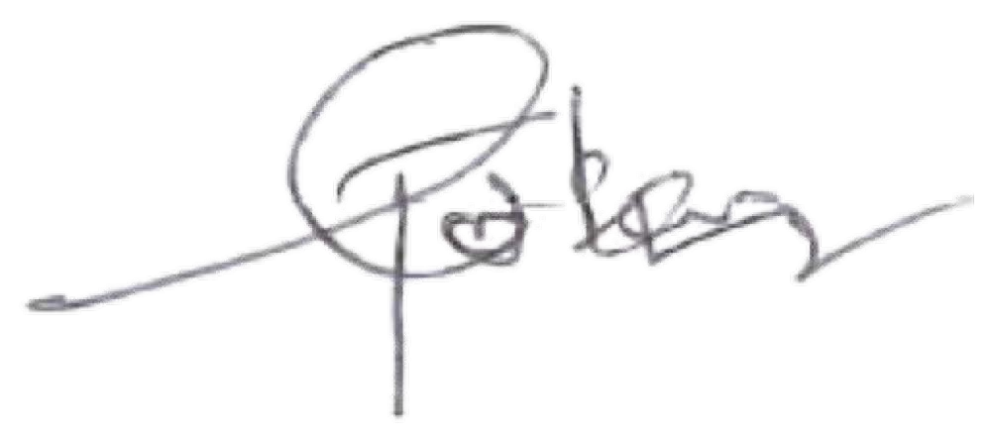

Name: ______________________________ Role: ___________Jonathan Obiegba Lead Developer_______________

Signature: Date: 17-02-2022



Oluwabusayo Adeyemi

Name: _________________________________Role: __________________________Solution Architect

Signature: Date: 17-02-2022

Shola Akinnukawe

Name: _________________________________Role: __________________________Head, EBOC

Signature: Date: 17/03/2022

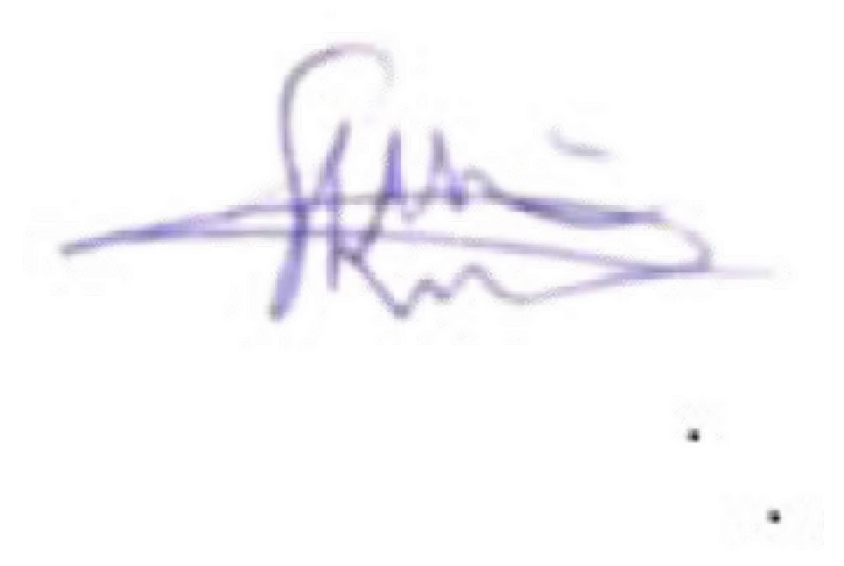

Name: _________________________________Role: __________________________

Signature: Date: